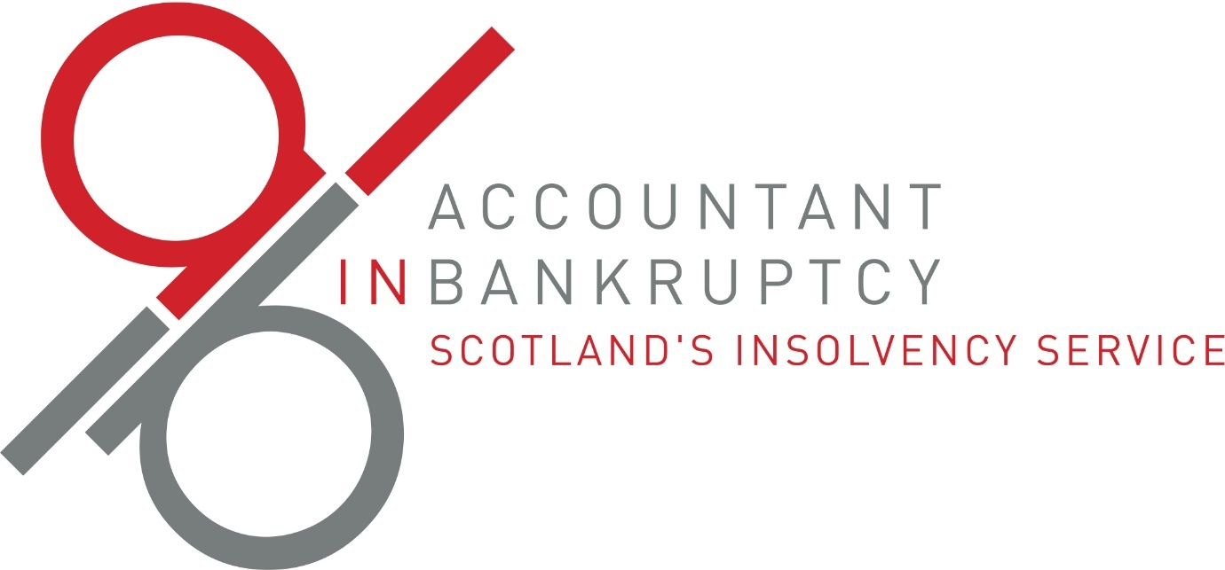

# Trust deed information document

## Key Facts – Protected Trust Deeds (PTDs)

## What is a Protected Trust Deed?

A Protected Trust Deed is a legal way to help you pay back some or all your debts. You make regular payments to a trustee, an insolvency professional who manages your debts and pays your creditors (the people you owe money to). If most of your creditors agree, they must also follow the PTD terms, which stops them from trying to collect the debt.

## Monthly payments

Your trustee will help you work out how much you can afford to pay each month based on your income and expenses. Be sure to include costs for disabilities or caring for others.

## Your assets

If you own valuable items, like a house or car, you might need to sell them to pay your debts. Your trustee can suggest other options, like having a family member buy your share of the house or making extra payments. Essential items such as household items are not affected by this.

## How long does it last?

A PTD usually lasts 4 years, but it can be longer if you have valuable property.

## Contact from creditors

While you are in a PTD, creditors cannot collect debts from you, but they can still send you important documents, like annual statements.

## Fees

Your trustee will charge fees for managing the PTD. These fees come from your monthly payments. At first, more of your payment will go to fees, but over time, more will go to your creditors. Your trustee will explain the fees to you before the PTD starts. These fees do not affect what you must pay, or for how long.

## Changes in your finances

If your financial situation changes, you must tell your trustee right away. Your payments will be reviewed at least once a year and can go up or down based on what you can afford. If you get extra money, like an inheritance, you must inform your trustee.

## Working with your trustee

You need to work with your trustee by giving them information and making agreed payments. If you don’t, your PTD could be cancelled, and your trustee might try to make you bankrupt. It’s important to follow the rules so your debts can be cleared.

## Stopping payments or failure of the PTD

If you stop making payments without permission, your trustee might take money directly from your wages or extend the time of your PTD. If the PTD fails because you do not make your payments or co-operate, creditors can start asking for payment again and may add fees. You won’t get back any money you paid if the PTD is cancelled.

## Impact on your credit rating

A PTD will lower your credit score and will stay on your credit report for 6 years. This can make it harder to get loans or mortgages.

## Public record

Your PTD will be listed in the Register of Insolvencies, which anyone can see. Your details will stay there for the duration of the PTD and will be removed 12 months after it ends.

## After the PTD

Once you finish the PTD and make all required payments, you’ll get a certificate that says your debts included in the PTD are written-off.

## If you die during a PTD

If you pass away while in a PTD, the PTD continues. Your estate (what you leave behind) will pay your debts and the costs of managing the PTD before anything goes to your family.

## When a PTD might not be right for you

If you can pay off your debts in full over a reasonable time, other options might be better, like the [Debt Arrangement Scheme](https://www.mygov.scot/browse/money-and-tax/money-and-debt-advice/debt-solutions/das). If you have a lot of equity in your property, refinancing might work. If you think you can’t keep up with payments for 4 years or more, [bankruptcy](https://www.mygov.scot/browse/money-and-tax/money-and-debt-advice/debt-solutions/bankruptcy-category) might be a better choice. A [comparison table](https://aib.gov.uk/publications/debt-solutions-comparison-table) has been published on the AiB website to help you make an informed choice on the options available.

## Time to think

Once you have received your advice, your trustee will advise that you must wait at least 3 days before signing the trust deed. This gives you time to consider your options and an opportunity seek further advice if you believe this would be helpful.

## Further help

For free advice on managing debt:

* contact your local Citizens Advice Bureau or the money advice unit of your local authority
* visit websites like [cas.org.uk](https://www.citizensadvice.org.uk/) or [moneyadvicescotland.org.uk](https://www.moneyadvicescotland.org.uk/)
* more information is also available at [mygov.scot](https://www.mygov.scot/browse/money-and-tax/money-and-debt-advice/debt-solutions#:~:text=Debt%20solutions%20include%20bankruptcy%2C%20the,you%20choose%20a%20debt%20solution.)