Scottish Statutory Debt Solutions Statistics

April 2022 to March 2023
Table of Contents
Main Points for April 2022 to March 2023 2
Things you need to know about this release 3
Statutory moratorium on diligence 4
Awards of Bankruptcy 6
Discharge from bankruptcy 12
Protected Trust Deeds 15
PTDs concluded 20
Debt Arrangement Scheme 25
Outcome of DPPs 30
Corporate Insolvency 32
Average debt level by type of debt solutions 34
Average contribution level by type of debt solutions 35
Background information 37
Statutory Debt Solutions legislation 41
Glossary 45
An Experimental Statistics publication for Scotland 48

Released: 02 August 2023
Next update: 07 August 2024
Official Statistics Label: Experimental Statistics
Provisional figures: With the exception of statistics already reported in the quarterly Scottish Statutory Debt Solutions Statistics publications, figures presented in this annual publication remain provisional and subject to revision.
Authors: Catherine McAuley and Lucy Horner
Contact details: AiB Statistics team
Data used in this release: The full data for the financial year 2022-23 and earlier years (up to 2015-16 whenever available) can be found in the following link - Scottish Statutory Debt Solutions Statistics: 2022-23
Media enquiries: AiB Communications team
Twitter: AiB_updates; ScotStat
We want your feedback: We welcome any feedback on any aspect of these statistics and invite users to complete our feedback survey and/or contact us by email.

Main Points for April 2022 to March 2023
There were 8,001 personal insolvencies (bankruptcies and protected trust deeds (PTDs)) in Scotland in 2022-23, 232 (3.0%) more than in the previous financial year 2022-23.
A total of 2,357 bankruptcies were awarded during this year - a 2.3% increase on 2021-22. PTDs increased by 3.3% to 5,644 over the same period.
There were 3,268 applications for moratoria granted in 2022-23. This is 103 (3.3%) more than the figure granted in 2021-22.
There were 4,947 debt payment programmes (DPPs) under Debt Arrangement Scheme (DAS) approved in 2022-23, compared with 4,489 approved in 2021-22, an increase of 10.2%.
In 2022-23, around £47 million was repaid from debtors under DAS compared with the £43.8 million repaid in 2021-22.
For all bankruptcy cases (excluding Minimal Asset Process) concluded in 2022-23, the mean (average) dividend paid to ordinary creditors including those with zero dividends was 13.1 pence in the £, compared with 9.2 in 2021-22.
For all PTDs concluded in 2022-23, the mean dividend paid to ordinary creditors including those with zero dividends was 15.8 pence in the £, compared with 16.0 in 2021-22.
Corporate insolvencies increased from 854 in 2021-22 to 1,132 in 2022-23.
Chart 1 below shows the trend of personal insolvencies and DPPs under DAS since 2005-06.

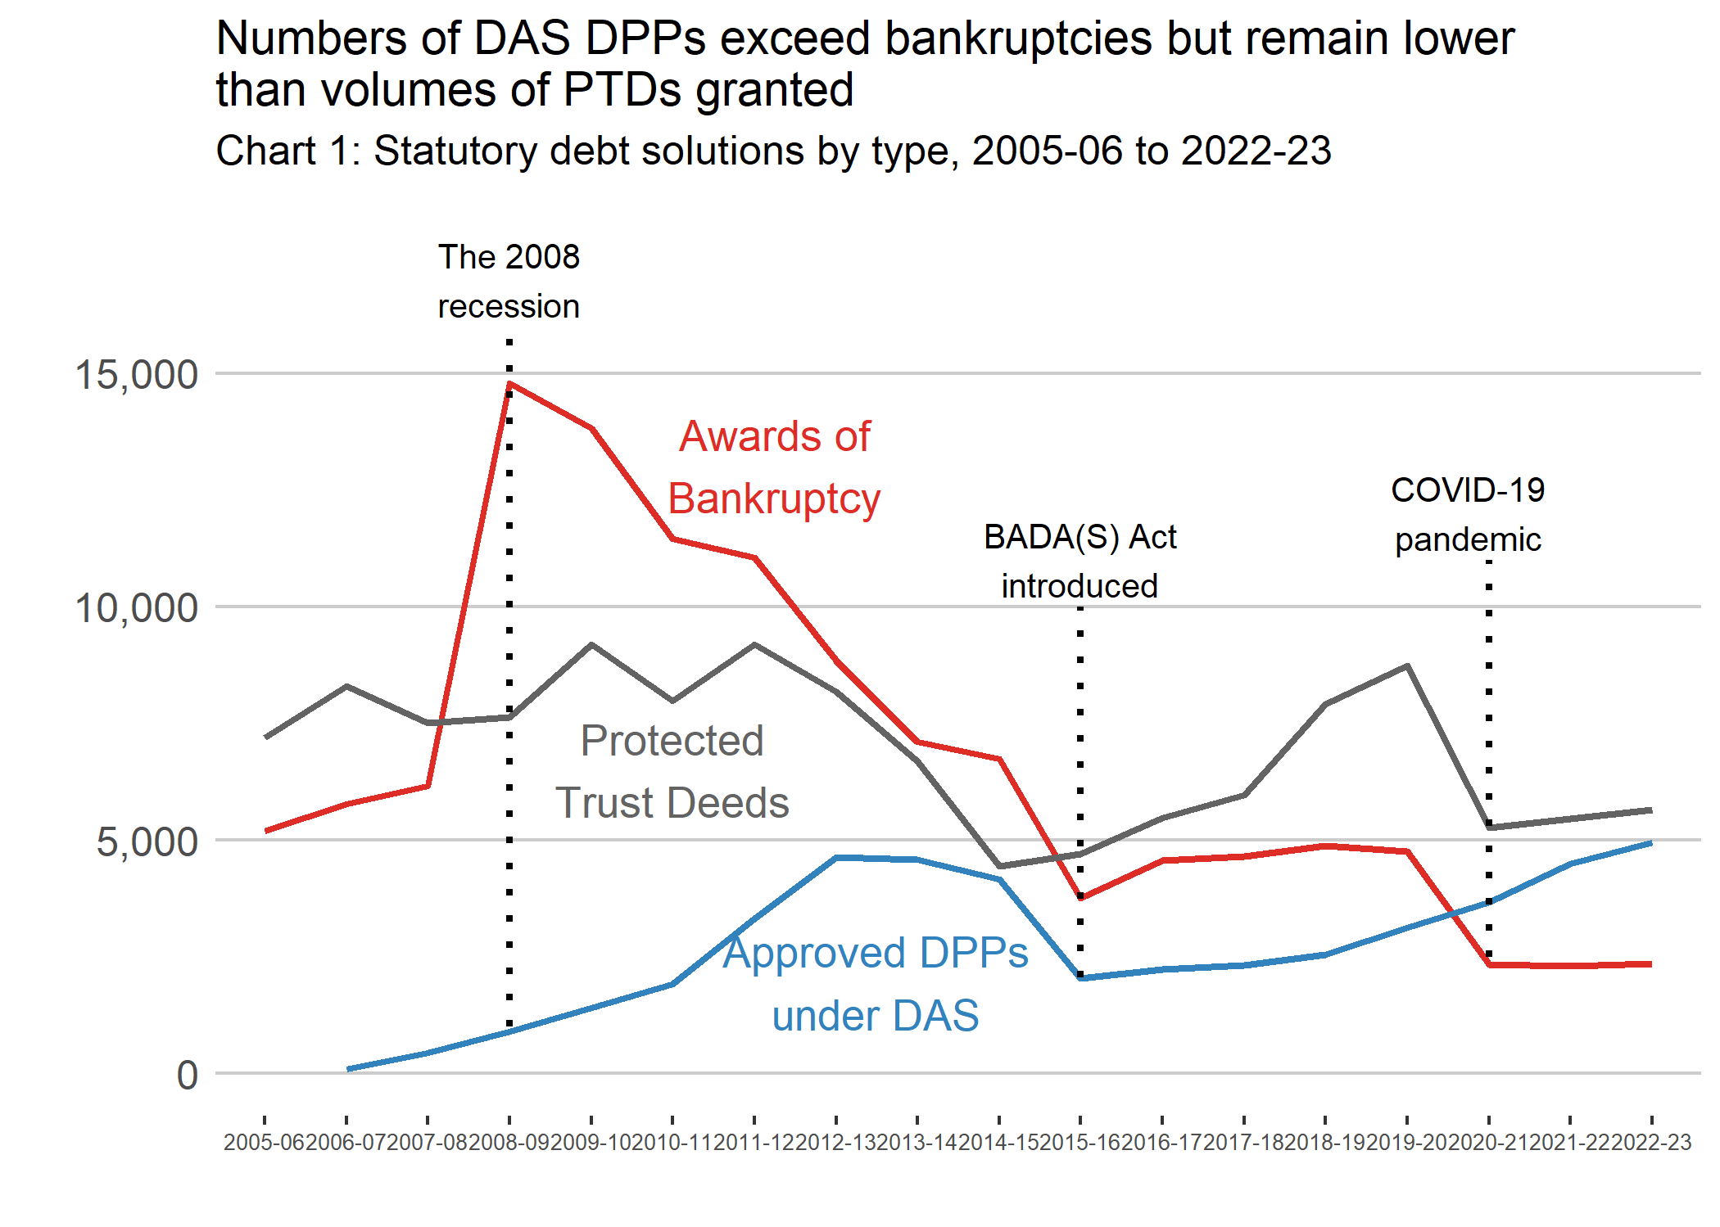 Source: Scottish Statutory Debt Solutions Statistics: April to June 2023 (2023-24 Quarter 1)

Things you need to know about this release

Experimental Statistics label
Experimental statistics are a type of official statistics that are undergoing development. In this new publication, the experimental statistics label has been used with the aim for compliance with the Code of Practice for Statistics. These statistics are currently being developed and have been published to involve users and stakeholders in their development, and to build in quality and understanding at an early stage.
Section 6.1 of the 2007 Statistics and Registration Service Act defines official statistics as statistics produced by the UK Statistics Authority, government departments (including executive agencies), the Devolved Administrations in Scotland, Wales and Northern Ireland, any other person acting on behalf of the Crown or any other organisation named on an Official Statistics Order.
Under the Act, official statistics should comply with the Code of Practice for Statistics and fall within the scope of the Office for Statistics Regulation, which assesses their compliance against the Code of Practice.
Further information on the standards of official statistics in Scotland is available here - About our statistics - gov.scot.
The exact publication date will be pre-announced through a 12-month release calendar, giving a specific release date at least four weeks in advance where practicable – Official statistics: forthcoming publications - gov.scot

Development work programme
Over the next year, a work programme to continuously evaluate and improve the existing output will be carried out. More specifically, the work programme for will focus on three areas: User needs; Completeness of the data collected; Quality assurance processes.
Part of the aim of this publication is to engage with users and potential users of our statistics in order to assess the suitability and value of the statistics released. Users are central to the statistics that AiB produce, and we want to ensure that key information about each of the statutory debt solutions is easily accessible and valued. Therefore, we are seeking your feedback on this publication, to improve the product and better support our user base. Please do get in touch with us via email and/or via our anonymous online feedback survey and we will share this with our stakeholders. No information about particpants is collected without their explicit consent.
Currently, all statistics for the financial year 2021-22 and 2022-23 are included in this publication. Some statistics for earlier years up to 2015-16 are also included. AiB is continuously working on improving the quality and completeness of this statistical publication. The major limitation to this work is that statistics are derived from administrative systems owned by AiB. Some of these systems have been long decommissioned, and some records are permanently deleted according to AiB’s data retention and destruction policy. Hence, the data for earlier years is limited. We will include estimates for early years if these are available during the work programme.

Statutory moratorium on diligence
A moratorium provides protection from creditor debt enforcement. This protection is available to individuals as well as the following entities:
- a trust in respect of debts incurred by it
- a partnership (including a dissolved partnership)
- a corporate body
- an unincorporated body
- a limited partnership (including a dissolved limited partnership) within the meaning of the Limited Partnerships Act 1907, or jointly by, as the case may be, the trustees, partners or members of any of those persons.
Individuals can request a moratorium if they need a period of breathing space to consider whether to apply for bankruptcy, DAS or grant a trust deed.
Due to the COVID-19 pandemic, emergency legislation was enacted to temporarily extend the duration of the moratorium from six weeks to six months. In addition to this, under normal circumstances a moratorium cannot be granted more than once in any 12-month period. This rule was also set aside temporarily as a result of the pandemic. This has now been reinforced as of 30 September 2021. From 1 October 2021, moratorium protection cannot be provided where an application has been made in the previous 12 months. The Coronavirus (Recovery and Reform) (Scotland) Act continued this enhanced protection.
Overall, there were 3,268 applications for moratoria granted in 2022-23. This is 103 (3.3%) more than the figure granted in 2021-22.
Chart 2 shows the consistently decreasing trend of moratorium applications since 2015-16 until 2020-21.

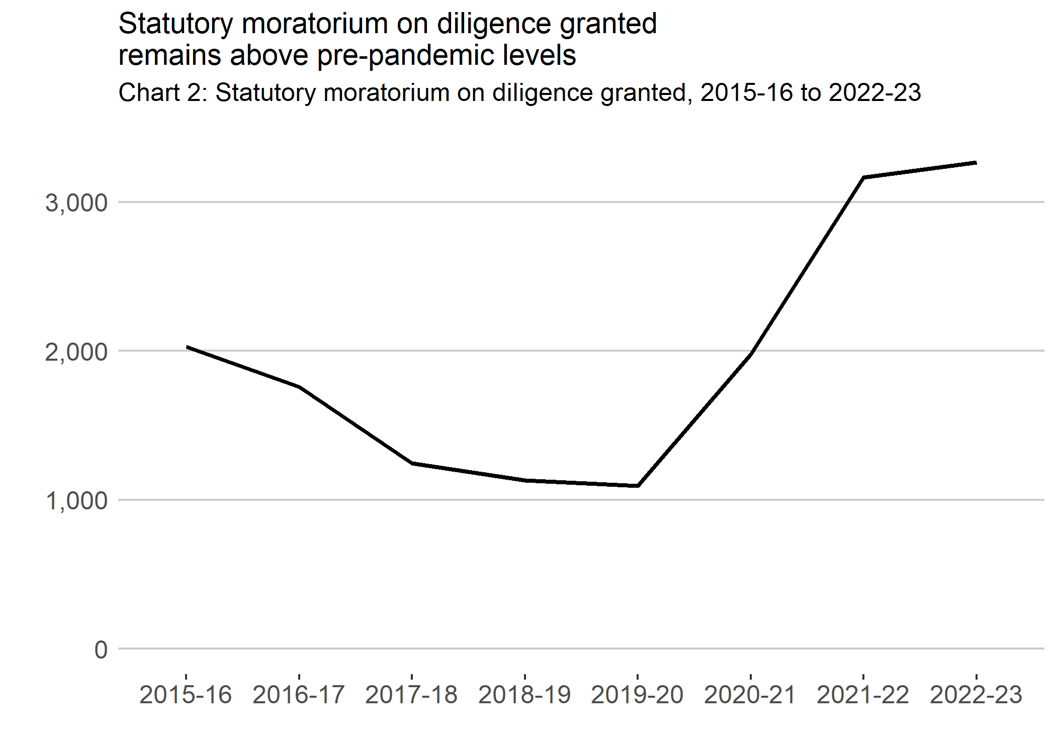
In order to determine how many individuals who successfully applied for a moratorium between 2019-20 and 2022-23, and entered any one of the three statutory debt solutions, a data matching exercise with moratorium, bankruptcy (excluding creditor petitions), PTDs and DAS datasets was carried out. The important limitation here is, although we hold the most complete record of all statutory debt solutions and statutory moratorium on diligence, there is no unique identifier that would allow us to link any two of these records.
Therefore, it was necessary to carry out a data linking (or matching) exercise. This is a process that temporarily brings together two or more sets of administrative data in order to produce statistics on how many accepted moratoria on diligence eventually lead to a statutory debt solution. It is rare for all entries in each administrative database system to be error-free, and each administrative database system is not standardised across systems.
For this reason, we have adopted the inexact (fuzzy) matching exercise which purpose is to identify the likelihood that two records are a true match based on whether they are similar or not on the following identifiers: first name; surname; current addresses; postcode; date of birth. Note previous addresses are not considered, and the future work programme may include previous addresses.
Consequently, there is a small chance that a low number of erroneous false positive matches have been accidentally included in this analysis. Similarly, the exercise could incorrectly exclude the false negative matches that are considered true matches. While great care has been taken to ensure the figures derived from the matching exericise are accurate, caution is needed when interpreting such figures.
With this limitation in mind, based on the data matching exercise there were 2,495 individuals who successfully applied for a moratorium between 2019-20 and 2022-23, and entered any one of the three statutory debt solutions. Of those 2,495 individuals, around 51.6% entered bankruptcy, 14.1% entered a PTD and 34.3% entered a Debt Payment Programme (DPP) under DAS.

Awards of Bankruptcy
Bankruptcy (also known as sequestration in Scotland) is a legal declaration that a person cannot pay their debts. If a person is declared bankrupt, control of some things that they own are passed to a trustee who may sell them to pay money owed to creditors.
Table 1 below shows a high level summary of bankruptcies in Scotland, broken down by type of bankruptcy and type of trustee organisation. There were 2,357 bankruptcies awarded in 2022-23, an increase of 2.3% when compared with 2021-22.

Table 1: Number of awards of bankruptcy by financial year and type of bankruptcy

Financial year of the awarded date | 2018-19 | 2019-20 | 2020-21 | 2021-22 | 2022-23 | Annual change (%)
Creditor petitions | 994 | 910 | 164 | 136 | 331 | 143.4%
of which trustee: AiB | 787 | 654 | 101 | 106 | 254 | 139.6%
of which trustee: Insolvency practitioner | 207 | 256 | 63 | 30 | 77 | 156.7%
Trust deed petitions | 10 | 5 | 0 | 0 | 0 | [z]
of which trustee: AiB | 5 | 2 | 0 | 0 | 0 | [z]
of which trustee: Insolvency practitioner | 5 | 3 | 0 | 0 | 0 | [z]
Debtor applications | 3,869 | 3,833 | 2,167 | 2,169 | 2,026 | -6.6%
of which trustee: AiB | 3,363 | 3,291 | 1,964 | 1,975 | 1,895 | -4.1%
of which trustee: Insolvency practitioner | 506 | 542 | 203 | 194 | 131 | -32.5%
of which debtor application: Minimal Asset Process | 2,181 | 2,020 | 1,514 | 1,536 | 1,404 | -8.6%
of which debtor application: Full Administration | 1,688 | 1,813 | 653 | 633 | 622 | -1.7%
Total awards of bankruptcy | 4,873 | 4,748 | 2,331 | 2,305 | 2,357 | 2.3%
Source: Accountant in Bankruptcy

Awards of bankruptcy can be grouped into three types:
- debtor application - application made by the debtor to The Accountant in Bankruptcy
- creditor petition - applications to the court by a creditor to pursue the sequestration of a debtor
- trust deed petition - applications where the trustee under a trust deed has applied to the court for the debtor’s sequestration
The majority (86.0%) of bankruptcies were initiated through debtor applications. The number of bankruptcies awarded through debtor applications decreased by 6.6% in 2022-23 when compared with 2021-22.
Awards of bankruptcy through creditor petitions increased by 143.4% from 136 in 2021-22 to 331 in 2022-23. There were no trust deed petitions awarded in 2022-23.
Chart 3 below shows the recent trend in bankruptcies by type since 2015-16. The total awards of debtor applications have decreased by 21.9% in 2022-23 when compared with 2015-16. Therefore, the 2022-23 level remains below levels between 2015-16 and 2019-20.
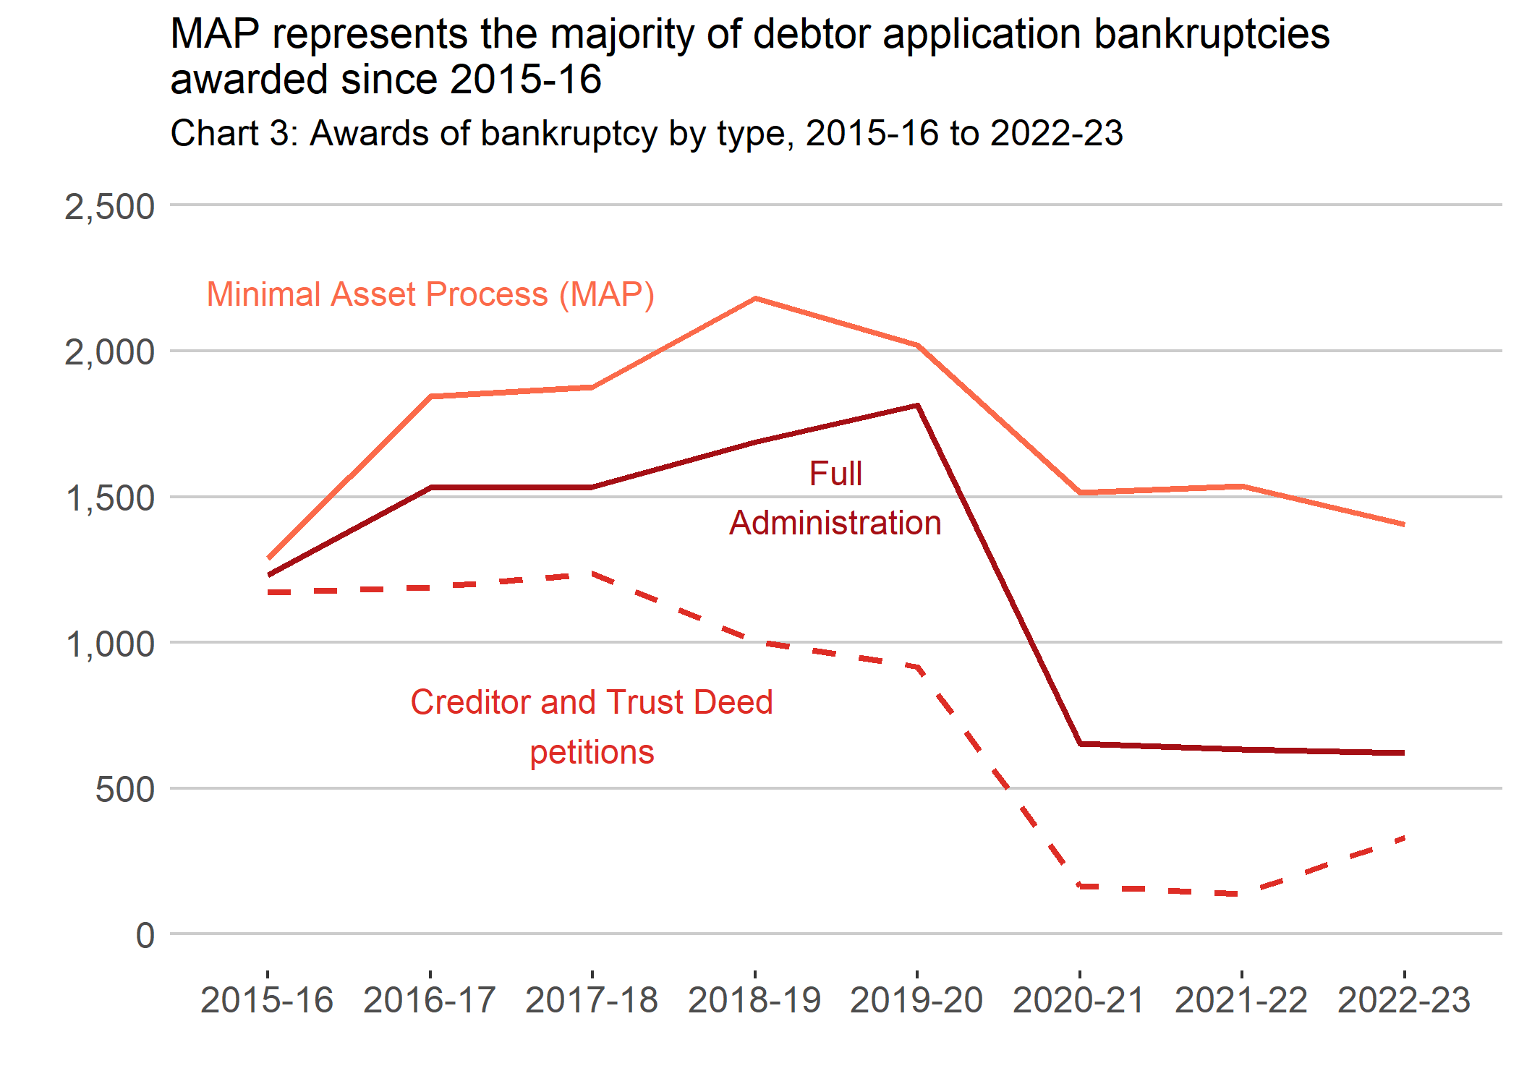

Type of debtor applications
In 2022-23, there were 2,026 awards of bankruptcy arising from debtor applications.
There are two types of debtor applications for bankruptcy - Minimal Asset Process (MAP) or Full Administration. In 2022-23, around 69.3% of bankruptcies awarded through debtor applications were MAP cases with the remaining cases being Full Administration.
MAP bankruptcy replaced the Low Impact Low Asset (LILA) route in April 2015. The number of LILA bankruptcy awards followed the declining trend in overall bankruptcies since 2008-09. There was a spike in activity in April to June 2012 - likely as a result of the scheduled increase in fees to access bankruptcy being introduced on 01 June 2012. The introduction of the Bankruptcy and Debt Advice (Scotland) (BADA(S)) Act 2014 in April 2015, was most likely cause for the sharp decline in the number of bankruptcies awarded in April to June 2015.
Not all debtor applications for bankruptcy result in an award being made and applications can be rejected (criteria for bankruptcy not met) or returned (application errors).
Applications for bankruptcy showed a small decrease in 2022-23 when compared with the previous year. In 2022-23, 2,085 applications for bankruptcy were received by AiB, compared with 2,279 in 2021-22.

Awards of bankruptcy by trustee appointment
In Scotland, a trustee is appointed to administer each bankruptcy. The Accountant in Bankruptcy (The Accountant) will be the trustee unless an Insolvency Practitioner (IP) is nominated to act. The Accountant is appointed as trustee in all MAP cases as there is no estate or contributions to be administered - this was previously the case under LILA.
In 2022-23 the Accountant was appointed as trustee in 91.2% of bankruptcies awarded, compared with 90.3% of bankruptcy awards in 2021-22. In the remaining 8.8% of cases, an IP was the nominated trustee in 2022-23.
The Accountant does not seek appointment as trustee in bankruptcies in Scotland but may be appointed as a default trustee if no other nomination is made.
The number of cases where The Accountant was appointed as trustee was 2,149, an increase from 2,081 in 2021-22. The number of cases where an IP was appointed trustee decreased from 224 in 2021-22 to 208 in 2022-23.

Awards of bankruptcy by local authority area in 2022-23
The number of bankruptcies awarded can be shown by local authority areas, based on the applicant’s postcode. Using the estimated adult population (aged 16+) of each local authority, the number of bankruptcies per 10,000 adults can be calculated, providing a representative picture of the concentration of bankruptcies in Scotland.
Several elements such as access to debt advice, social perception of debt or ease of access to credit can affect the uptake of statutory debt solutions (bankruptcies awarded, PTDs registered and DAS DPPs approved). Consequently, the figures presented in this report cannot be regarded as evidence of the level of indebtedness or economic performance in any particular local authority.
The rate of bankruptcies per 10,000 adults in Scotland was 5 in 2022-23, the same rate as in 2021-22.
Local Authority Chart 1 and the associated heatmap that depict bankruptcy rates show that West Lothian was the local authority with the highest rate of bankruptcies per 10,000 adults in Scotland. West Dunbartonshire was the local authority area with the second highest rate of bankruptcies. Stirling and Dumfries & Galloway were with the lowest and second lowest rate of bankruptcies.
Awards of bankruptcy (and for other statutory debt solutions) by local authority and for previous years are available in the accompanying tables.

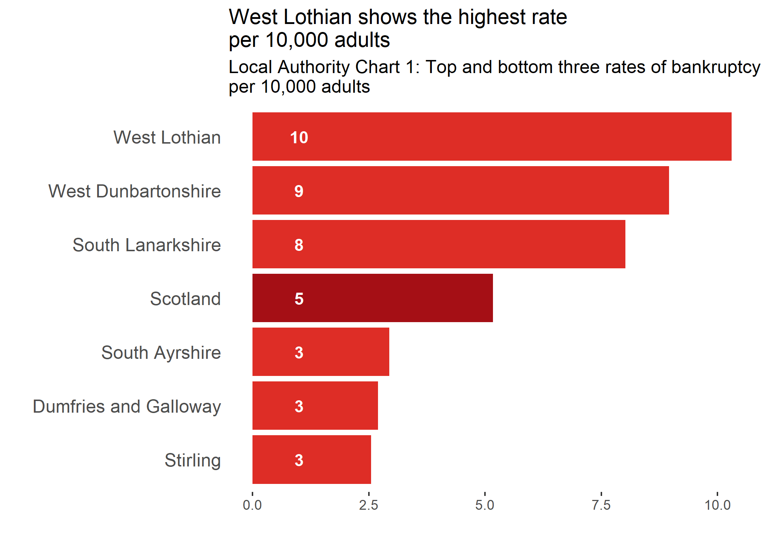
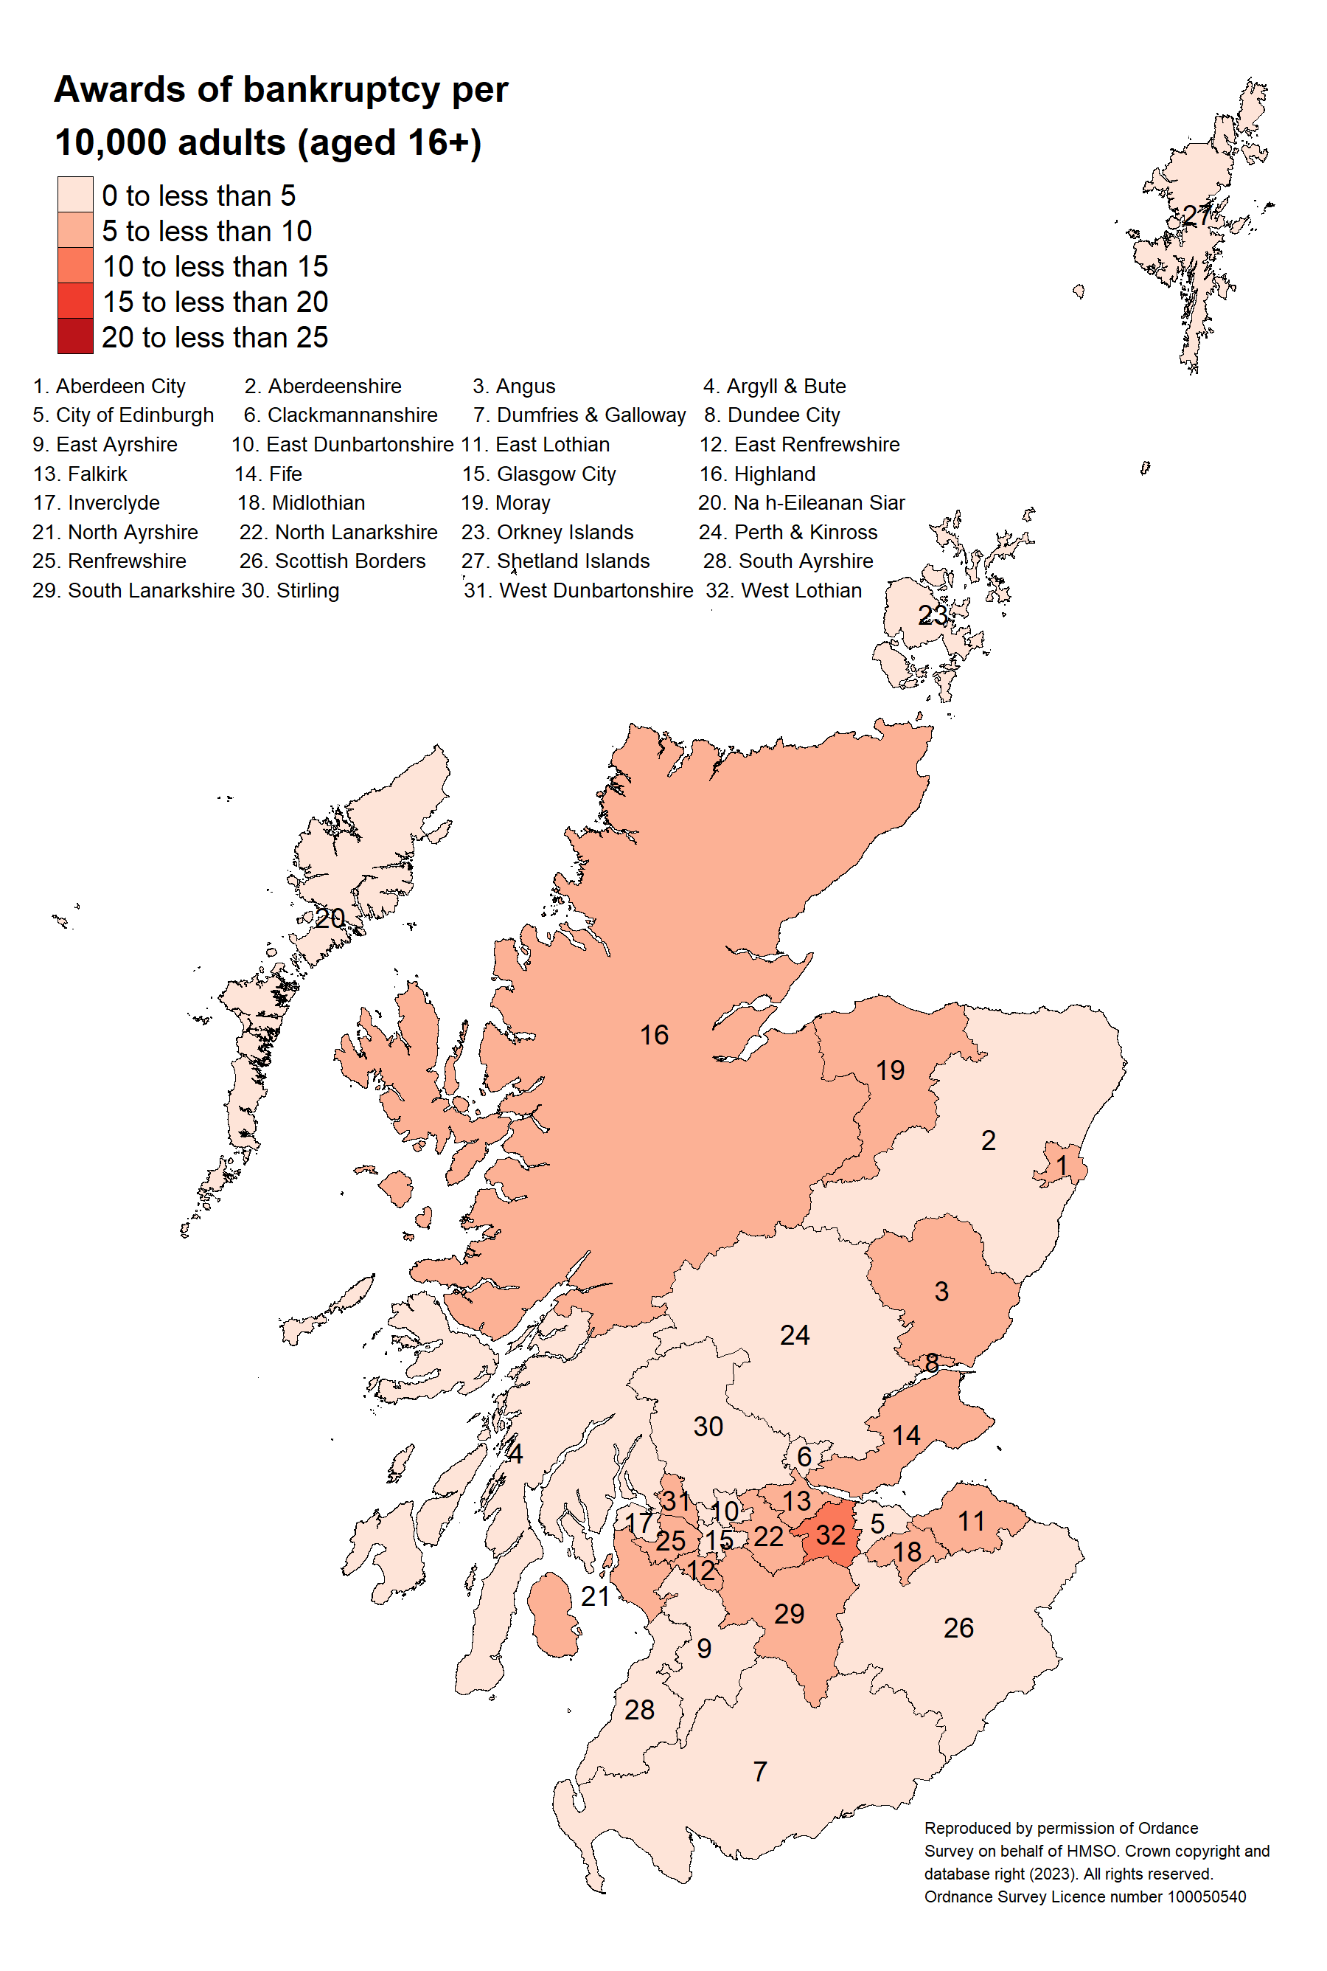

Bankruptcy Restriction Orders and Bankruptcy Restrictions Undertakings
Bankruptcy Restriction Orders (BROs) and Bankruptcy Restrictions Undertakings (BRUs) were introduced by The Bankruptcy and Diligence etc. (Scotland) Act 2007 and came into force on 01 April 2008. BRUs were subsequently abolished from April 2015 by the BADA(S) Act 2014, and hence there were no BRUs granted since 2016-17.
The purpose of BROs is to provide a level of protection to businesses and consumers from individuals that have demonstrated misconduct or recklessness before or after the date of bankruptcy. These individuals are held accountable for their actions by the imposition of bankruptcy restrictions for an extended period of time. BROs for a period of between two, but less than five years are imposed by AiB while BROs of a longer duration require an application through the court.
Restrictions are imposed in relatively small numbers when compared with the overall caseload of AiB. In 2022-23, there was a decrease in BROs granted from 8 in 2021-22 to 2 in 2022-23. The BADA(S) Act which came into force in 2015 conferred a new power on AiB to withhold the discharge of non-cooperating bankrupts. This change has contributed to the reduction of BRO volumes in recent years.

Discharge from bankruptcy
A debtor in a bankruptcy will normally be bankrupt for one year. After this period they may be discharged. Although the debtor is discharged, the administration of the bankruptcy continues until the trustee has dealt with all of the estate and accounted for their work so that they can seek their own discharge. A debtor must continue to cooperate with the trustee until the trustee’s discharge.
Table 2 shows that, in 2022-23 there were 2,797 bankruptcies discharged (based on discharge of the trustee), a 27.1% decrease on the previous year.

Table 2: Number of bankruptcies concluded by financial year and type of bankruptcy
Financial year of the trustee discharge date | 2018-19 | 2019-20 | 2020-21 | 2021-22 | 2022-23 | Annual change (%)
Creditor and trust deed petitions | 1,097 | 797 | 728 | 650 | 415 | -36.2%
Debtor applications | 4,518 | 4,157 | 3,509 | 3,188 | 2,382 | -25.3%
of which debtor application: Minimal Asset Process | 1,992 | 2,146 | 1,694 | 1,571 | 1,514 | -3.6%
of which debtor application: Full Administration | 2,526 | 2,011 | 1,815 | 1,617 | 868 | -46.3%
Total number of bankruptcies concluded | 5,615 | 4,954 | 4,237 | 3,838 | 2,797 | -27.1%
Source: Accountant in Bankruptcy

When the trustee in a bankruptcy is discharged, any funds gathered in respect of debts are divided among the creditors depending on the type of debt included in the bankruptcy. Secured debt is backed by some form of collateral, for example, secured debt over property. Preferred debt is payable before ordinary and postponed debts in a bankruptcy, PTD, or the winding up of a company.
It should be noted, however, that the protected status of many preferred creditors was abolished following revisions to the legislation in September 2003. Ordinary debt is any other type that is not preferred or secured.
Table 3 shows the number of awards concluded during 2022-23 and the dividend outcome of the discharged cases.

Table 3: Balance of bankruptcy cases by financial year and whether a dividend was payable or not
Financial year | 2018-19 | 2019-20 | 2020-21 | 2021-22 | 2022-23
Live cases at the start of the financial year | 10,009 | 9,267 | 9,061 | 7,155 | 5,622
New awards of bankruptcy | 4,873 | 4,748 | 2,331 | 2,305 | 2,357
New discharges of bankruptcy | 5,615 | 4,954 | 4,237 | 3,838 | 2,797
of which: Recalls | 44 | 73 | 34 | 41 | 48
of which: Discharged Minimal Asset Process (no dividend) | 1,992 | 2,146 | 1,694 | 1,571 | 1,514
of which: No dividend was payable | 2,518 | 1,950 | 2,050 | 1,672 | 866
of which: Dividend payable to preferred creditors only | 2 | 2 | 0 | 1 | 0
of which: Dividend payable to ordinary creditors | 1,059 | 783 | 462 | 548 | 371
Live cases at the end of the financial year | 9,267 | 9,061 | 7,155 | 5,622 | 5,182
Source: Accountant in Bankruptcy

Of the bankruptcies concluded by discharge of the permanent trustee, 70.0% resulted in no dividend payable to creditors and 30.0% resulted in a dividend payable to ordinary creditors only. This includes cases where a dividend could be payable and therefore excludes MAP cases.
If all bankruptcy cases that concluded by discharge of the trustee in 2022-23 are considered, including MAP cases, a dividend was paid to ordinary creditors in 13.3% of cases.
Around 48.0% of cases where ordinary creditor dividends were paid resulted in a dividend of less than 25 pence in the £, which is less than the 55.1% of cases in 2021-22. Furthermore, 26.4% of cases were paid at 100 pence in the £ plus interest, which is more than the 18.8% of the cases in 2021-22.
For all cases in which a dividend was payable, the mean dividend paid to creditors for all cases including those with zero dividends was 13.1 pence in the £, compared with 9.2 in 2021-22. In cases where The Accountant was appointed as trustee, the mean dividend was 18.1 pence in the £, compared with 7.6 pence in the £ for cases where a private sector trustee was appointed. Dividends are affected by the realised value of estate.
The above figures reflect the overall return to creditor as a proportion of the total debt claimed - these are equivalent to previous figures contained in the AiB Annual reports although these have been labelled as “Average dividends paid to creditors”.

Contracted out insolvency services
The Insolvency Service Framework allows AiB to use external providers to administer bankruptcy cases on its behalf, where The Accountant has been appointed trustee.
In 2022-23, 710 cases were contracted out and 708 contracted out cases were discharged. Of these discharged cases, 346 (48.9%) were cases with assets realised.
Further information on these cases including the value of assets realised and the expenses on realisation are shown in the accompanying tables. Note, these figures are rounded to the nearest thousand pound, and totals may not equal the sum of the constituent parts due to rounding.
The total value of assets realised was around £11.9 million. Heritable assets, which are properties in the form of land, houses, and buildings that become heritable by accession made up around 63.5% of the value of all assets realised. Ingathered contributions and funds made up 32.2% of the value of all assets realised.
The total expenses of realisation was around £2.7 million, the majority of which was made up of expenses on secured assets.

Protected Trust Deeds
A PTD is a formal debt solution where an agreement is made between a debtor and creditors to repay part or all of their debt. The debtor conveys their estate to an IP (the trustee) to administer for the benefit of creditors and the arrangement normally includes a contribution from income for a set period.
Table 4 below shows the number of trust deeds advertised and protected by financial year. There were 5,938 trust deeds advertised in 2022-23, a 1.3% increase on the previous year. Of the 5,938 trust deeds, around 94.9% did become protected eventually. Furthermore, there were 5,644 PTDs registered in 2022-23, a 3.3% increase on the previous year. In each financial year since 2015-16, more PTDs have been registered than awards of bankruptcy as seen in Chart 1.

Table 4: Number of advertised and protected trust deeds by financial year
Financial year of the advertised and protected date | 2018-19 | 2019-20 | 2020-21 | 2021-22 | 2022-23 | Annual change (%)
Number of advertised trust deeds | 8,849 | 9,467 | 5,042 | 5,859 | 5,938 | 1.3%
of which: Did become protected eventually | 8,040 | 8,748 | 4,735 | 5,518 | 5,633 | 2.1%
of which: Did not become protected | 809 | 719 | 307 | 341 | 305 | -10.6%
Number of protected trust deeds | 7,915 | 8,743 | 5,263 | 5,464 | 5,644 | 3.3%
Source: Accountant in Bankruptcy

Chart 4 below shows the increasing trend of PTDs since 2015-16 to 2019-20, followed by a decrease in 2020-21.

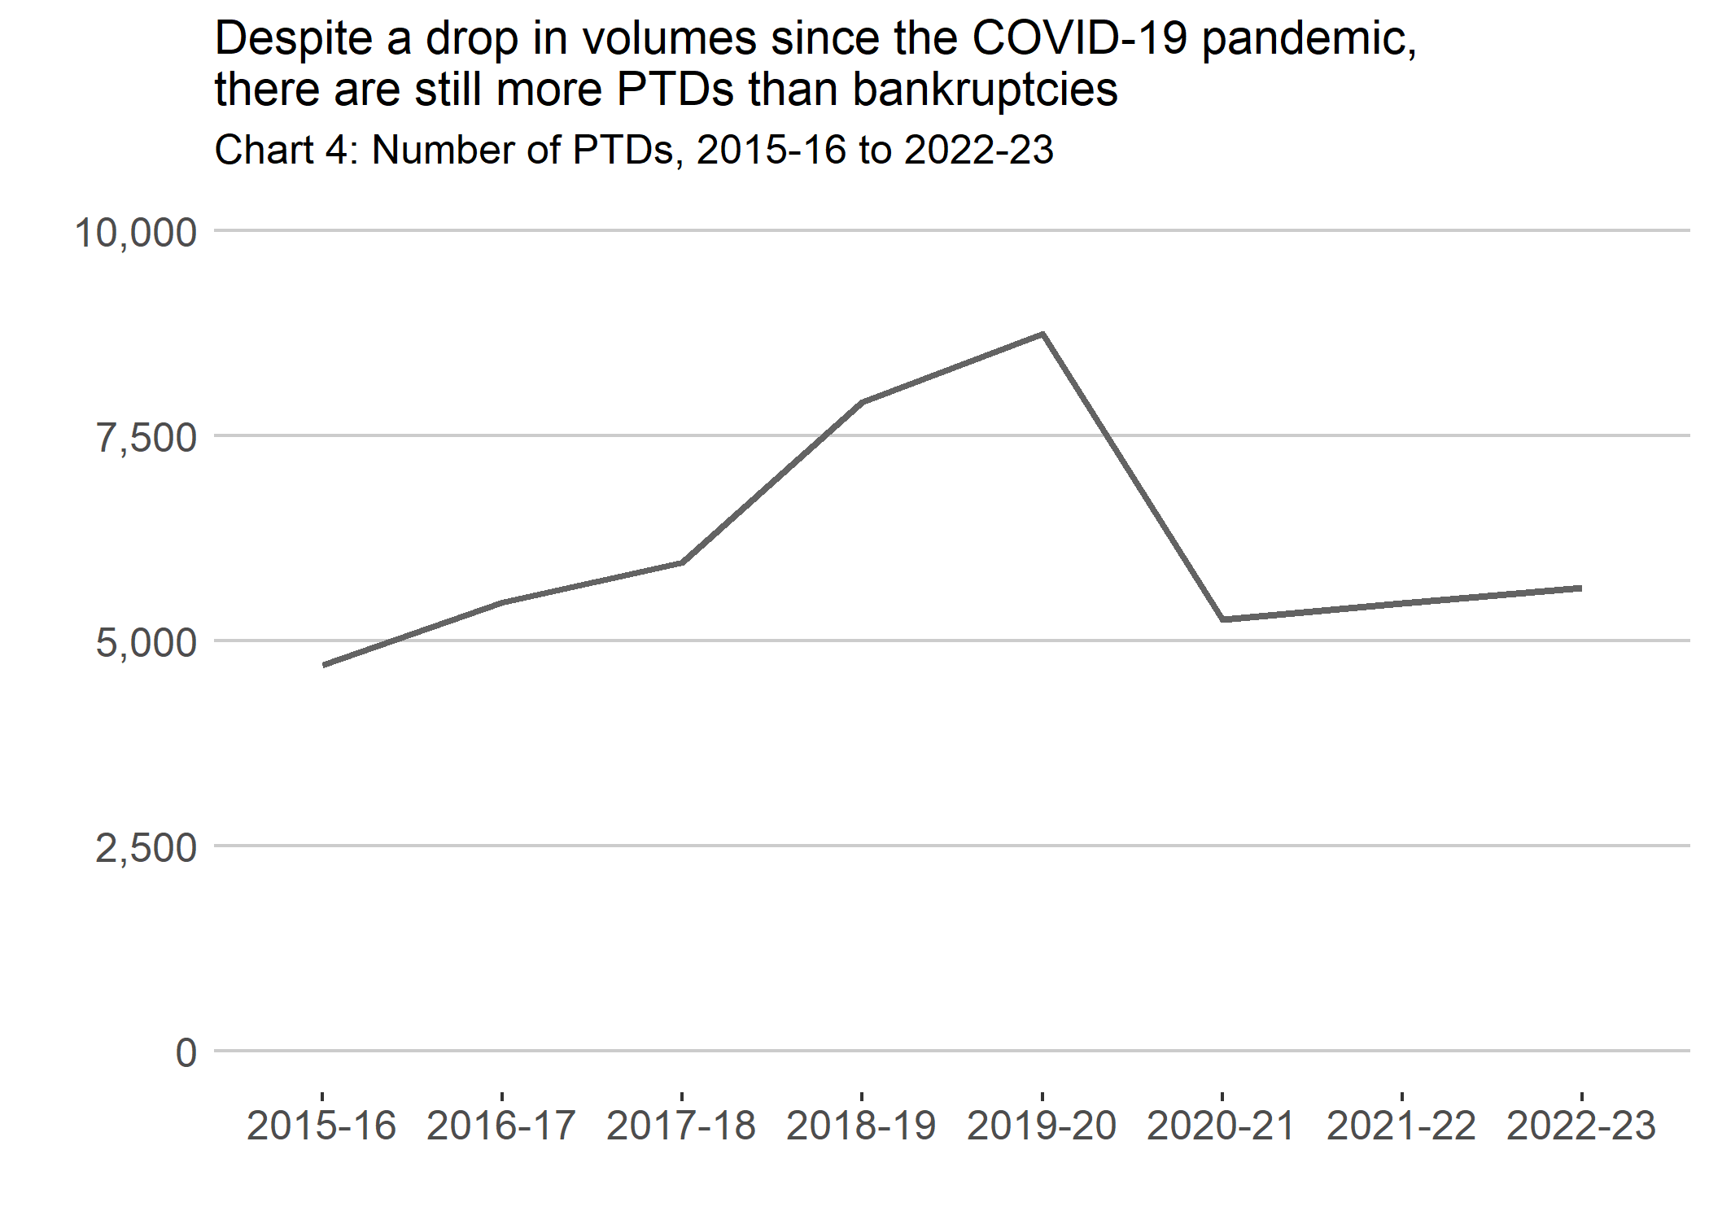

PTDs registered by local authority in 2022-23
The rate of PTDs per 10,000 adults in Scotland was 12 in 2022-23, unchanged from the rate of 12 in the previous financial year.
Local Authority Chart 2 and the associated heatmap that depict PTD rates show that North Lanarkshire was the local authority with the highest rate of PTDs per 10,000 adults, followed by Clackmannanshire and Midlothian.
Na h-Eileanan Siar, Orkney Islands and East Renfrewshire were the local authorities with the lowest rate of PTDs per 10,000 adults.
PTDs (and for other statutory debt solutions) by local authority and for previous years are available in the accompanying tables.

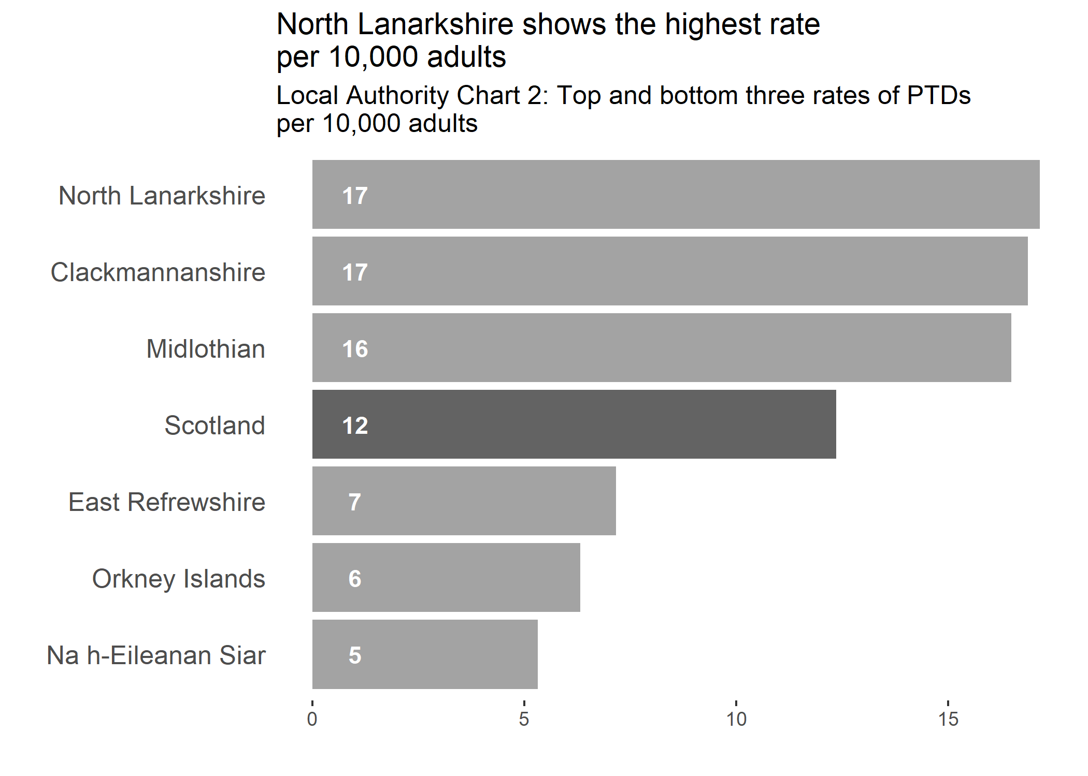

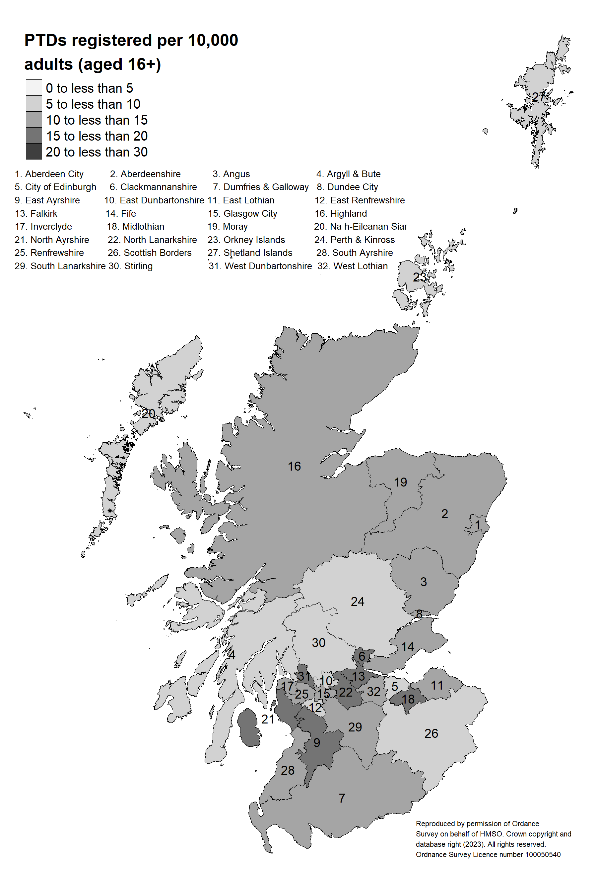

PTDs concluded
When the administration of a PTD is complete, the trustee must apply to creditors to be discharged.
In 2022-23, as Table 5 shows, 7,079 PTDs were concluded compared with 6,181 concluded in 2021-22. There were 5,421 cases (excluding all cases where only secured or preferred creditors were repaid) wound up and the division of funds following a trustee’s discharge during 2022-23. Of the 5,421 cases where ordinary creditor dividends are paid, 73.9% of cases paid at less than 25 pence in the pound, which is less than 77.6% of cases in 2021-22. 2.5% of cases paid at 100 pence in the pound plus interest, which is more than 2.0% in 2021-22.

Table 5: Balance of protected trust deeds by financial year and whether a dividend was payable or not
Financial year | 2018-19 | 2019-20 | 2020-21 | 2021-22 | 2022-23 | Annual change (%)
Live cases at the start of the financial year | 25,964 | 26,030 | 30,029 | 32,773 | 32,056 | -2.2%
New protected trust deeds registered | 7,915 | 8,743 | 5,263 | 5,464 | 5,644 | 3.3%
New protected trust deeds concluded | 7,849 | 4,744 | 2,519 | 6,181 | 7,079 | 14.5%
of which: Balancing item for total concluded | 110 | 71 | -5 | 0 | 1 | [z]
of which: Form 11 | 102 | 39 | 8 | 16 | 3 | -81.3%
of which: Form 7 | 7,637 | 4,634 | 2,516 | 6,165 | 7,075 | 14.8%
of which Form 7 only: PTDs in which the debtor is not discharged | 1,660 | 1,186 | 889 | 679 | 1,137 | 67.5%
of which: No dividend was payable to ordinary creditors | 1,887 | 1,372 | 1,011 | 972 | 1,656 | 70.4%
of which: Dividend payable to preferred creditors only | 1 | 1 | 0 | 3 | 1 | [z]
of which: Dividend payable to ordinary creditors | 5,974 | 3,377 | 1,513 | 5,206 | 5,421 | 4.1%
Live cases at the end of the financial year | 26,030 | 30,029 | 32,773 | 32,056 | 30,621 | -4.5%
Source: Accountant in Bankruptcy

In 2022-23, a dividend was paid to creditors in 76.6% of cases concluded in year, a decrease on the proportion in the previous year (84.3%). Excluding PTDs where the debtor is not discharged, a dividend was paid in 91.2% of cases concluded - for which dividend information is available - in 2022-23.
Table 6 shows the distribution of funds collected and allocated at the discharge of the trustee between 2018-19 and 2022-23 for cases concluded. In 2022-23, almost £58.4 million was ingathered, 7.6% more than the total receipts in 2021-22. Overall, 39.7% of total receipts was payable to creditors through a dividend compared with 37.9% in 2021-22, meaning the majority of total receipts were allocated to administration expenses.

Table 6: Summary of statistics on distribution of funds for protected trust deeds concluded by financial year
Financial year of the trustee discharge date | 2018-19 | 2019-20 | 2020-21 | 2021-22 | 2022-23 | Annual change (%)
Mean dividends for all cases (pence in the £) | 15.2 | 14.9 | 14.2 | 16.0 | 15.8 | [z]
Mean administration expenses (£) | 6,100 | 5,500 | 4,900 | 5,600 | 5,200 | -7.1%
of which: Dividend payable to ordinary creditors | 7,200 | 6,800 | 6,900 | 6,200 | 6,100 | -1.6%
of which: No dividend payable to ordinary creditors | 2,700 | 2,400 | 1,900 | 2,400 | 2,400 | 0.0%
Total administration expenses (£) | 48,242,000 | 26,318,000 | 12,418,000 | 34,588,000 | 36,773,000 | 6.3%
of which: Dividend payable to ordinary creditors | 43,177,000 | 23,030,000 | 10,490,000 | 32,292,000 | 32,861,000 | 1.8%
of which: No dividend payable to ordinary creditors | 5,065,000 | 3,288,000 | 1,928,000 | 2,296,000 | 3,912,000 | 70.4%
Total payable to preferred creditors (£) | 5,000 | 8,000 | 1,000 | 13,000 | 1,000 | [z]
of which: Dividend payable to ordinary creditors | 2,000 | 0 | 1,000 | 0 | 0 | [z]
of which: No dividend payable to ordinary creditors | 3,000 | 8,000 | 0 | 13,000 | 1,000 | [z]
Total payable to ordinary creditors (£) | 24,153,000 | 13,489,000 | 7,016,000 | 19,686,000 | 21,617,000 | 9.8%
of which: Dividend payable to ordinary creditors | 24,153,000 | 13,489,000 | 7,016,000 | 19,686,000 | 21,617,000 | 9.8%
of which: No dividend payable to ordinary creditors | 0 | 0 | 0 | 0 | 0 | [z]
Total receipts ingathered (£) | 72,400,000 | 39,815,000 | 19,435,000 | 54,287,000 | 58,391,000 | 7.6%
of which: Dividend payable to ordinary creditors | 67,332,000 | 36,519,000 | 17,507,000 | 51,978,000 | 54,478,000 | 4.8%
of which: No dividend payable to ordinary creditors | 5,068,000 | 3,296,000 | 1,928,000 | 2,309,000 | 3,913,000 | 69.5%
Source: Accountant in Bankruptcy

The average administration cost of a PTD that concluded with a dividend payable was £6,100 in 2022-23 compared with £6,200 in 2021-22.
For all PTDs including those with zero dividends, the mean dividend paid to ordinary creditors during 2022-23 was 15.8 pence in the £ compared with 16.0 pence in the £ in 2021-22.
In 2022-23, over £3.9 million was ingathered for PTDs concluded where no dividend was payable, compared with £2.3 million in 2021-22.
The average administration cost of a PTD that concluded with no dividend payable was £2,400 in 2022-23, the same amount as in 2021-22.

PTD Form 7 and Form 11 performance
The Form 7 and Form 11 returns detail the trustee’s actual statement of realisation and distribution of estate under a PTD. The following tables summarise the performance based on this information from the Form 7 returns.
The percentage of cases where administration costs have increased by 25% or more includes PTDs where there has been increased complexity or a lack of co-operation from the debtor, requiring the trustee to commit more time to the administration in these cases.
The number of PTDs where a dividend was not paid to creditors increased in 2022-23 by 70.4%. A proportion of these cases were not concluded, therefore the debtor was not discharged from liability to pay the debts included in the PTD.

Table 7: Summary of Form 7 and 11 performance for PTDs concluded in 2022-23
Trustee organisation | Number of PTDs | Number of PTDs in which no dividend was payable | Number of PTDs in which the debtor was not discharged | Form 3 mean dividend (p in the £) | Form 7 or 11 mean dividend (p in the £) | Number of PTDs in which admin costs increased by at least 25%
Number of approved Form 7 | 7,075 | 1,654 | 1,137 | 18 | 21 | 882
Carrington Dean | 4,924 | 1,138 | 814 | 17 | 18 | 788
Harper McDermott | 1,016 | 181 | 102 | 20 | 26 | 15
Interpath Advisory | 290 | 124 | 51 | 20 | 29 | 10
Azets | 163 | 30 | 25 | 16 | 29 | 10
Begbies Traynor | 145 | 41 | 18 | 17 | 20 | 11
Wylie & Bisset | 138 | 27 | 23 | 16 | 27 | 9
Hanover Insolvency | 103 | 13 | 13 | 16 | 19 | 3
Payplan Scotland | 83 | 1 | 1 | 24 | 28 | 13
William Duncan | 55 | 10 | 5 | 22 | 32 | 6
J3 Debt Solutions | 44 | 39 | 39 | 22 | 92 | 1
YEG Insolvency | 40 | 30 | 30 | 21 | 24 | 3
Others | 74 | 20 | 16 | 26 | 31 | 13
Number of approved Form 11 | 3 | 3 | [z] | [z] | 0 | [z]
Source: Accountant in Bankruptcy

Debt Arrangement Scheme
The DAS is a statutory debt management solution administered by AiB. Under the DAS, a debtor commits to a DPP which allows them to repay their debts based on their disposable income while they are protected from creditors taking any action against them to recover their debt.
In 2022-23, there were 4,947 approved DPPs under DAS compared with 4,489 approved in 2021-22, a 10.2% increase.
A DPP reaches completion when the debt in the programme has been paid in full, minus the fees paid to the DAS Administrator and the Payments Distributor. There were 1,918 completed DAS DPPs in 2022-23, a 10.2% increase when compared with 1,740 in 2021-22.
The debt included in live DPPs has increased from £337.0 million to £357.0 million by 31 March 2023. In 2022-23, around £47.0 million was repaid through DAS, a 7.3% increase when compared with £43.8 million repaid in 2021-22. Since the DAS (Scotland) Amendment Regulations 2018 came into force on 04 November 2019, creditors receive a minimum of 78% of debt owed to them from debtors on new DPPs approved (after DAS Administrator and payment distributor fees). Prior to this, the minimum was set at 90%. In 2022-23, £39.4 million was repaid to creditors.
Chart 5 below shows the recent trend in approved DPPs under DAS.

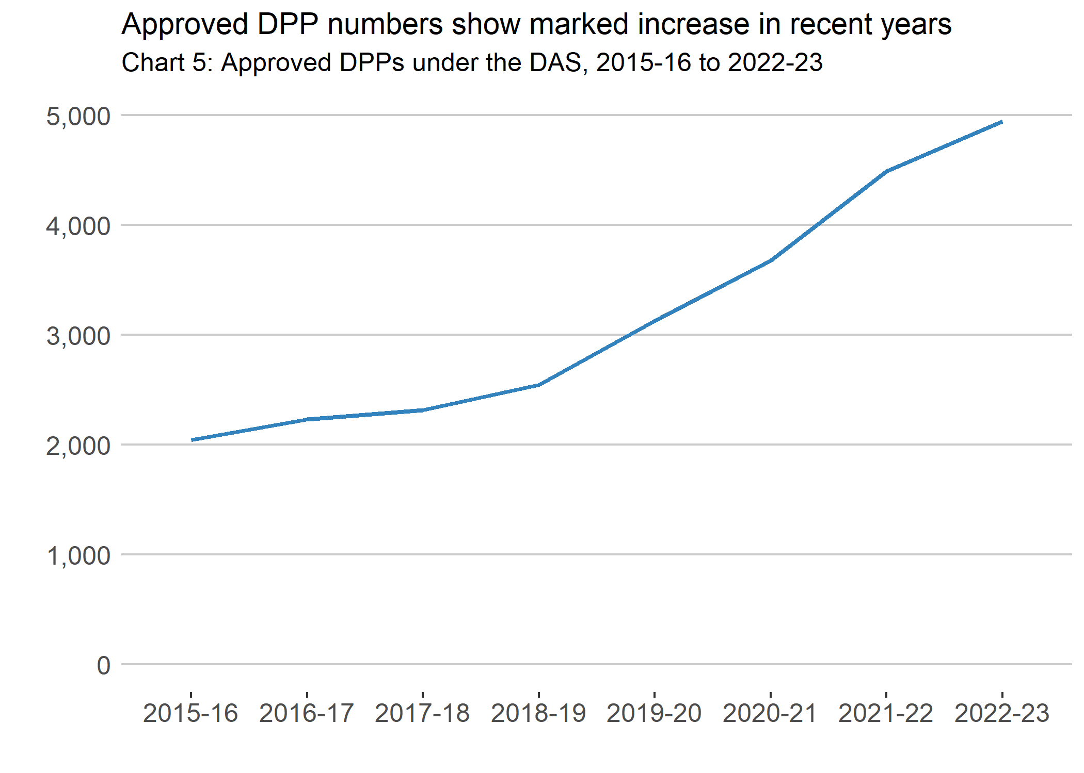
Table 8 below shows the high level summary of DAS DPPs since 2018-19 and includes information on the debt level in live DPPs and the amount repaid under DAS.

Table 8: Balance of DPPs under DAS by financial year
Financial year | 2018-19 | 2019-20 | 2020-21 | 2021-22 | 2022-23 | Annual change (%)
Live cases at the start of the financial year | 12,439 | 12,171 | 12,913 | 14,131 | 15,292 | 8.2%
Balancing item to match the published figures for live cases | 0 | 0 | 0 | 0 | -1 | [z]
New DPPs approved | 2,544 | 3,130 | 3,677 | 4,489 | 4,947 | 10.2%
of which: Joint applications | 348 | 356 | 311 | 363 | 339 | -6.6%
of which: Contains one single debt | 50 | 49 | 31 | 56 | 40 | -28.6%
New DPPs completed | 1,687 | 1,622 | 1,812 | 1,740 | 1,918 | 10.2%
New DPPs revoked | 1,125 | 766 | 647 | 1,588 | 1,599 | 0.7%
Live cases at the end of the financial year | 12,171 | 12,913 | 14,131 | 15,292 | 16,721 | 9.3%
Total amount of debts included in live DPPs (£ million) | 268 | 297 | 326 | 337 | 357 | 5.9%
Source: Accountant in Bankruptcy

DPPs by local authority in 2022-23
The rate of DAS DPPs per 10,000 adult population in Scotland was 11 in 2022-23 compared with 10 in 2021-22.
Local Authority Chart 3 and the associated heatmap that depict DAS rates show that North Lanarkshire was the local authority with the highest rate of DPPs per 10,000 adults with the lowest in City of Edinburgh.
Approved DPPs under DAS (and for other statutory debt solutions) by local authority and for previous years are available in the accompanying tables.

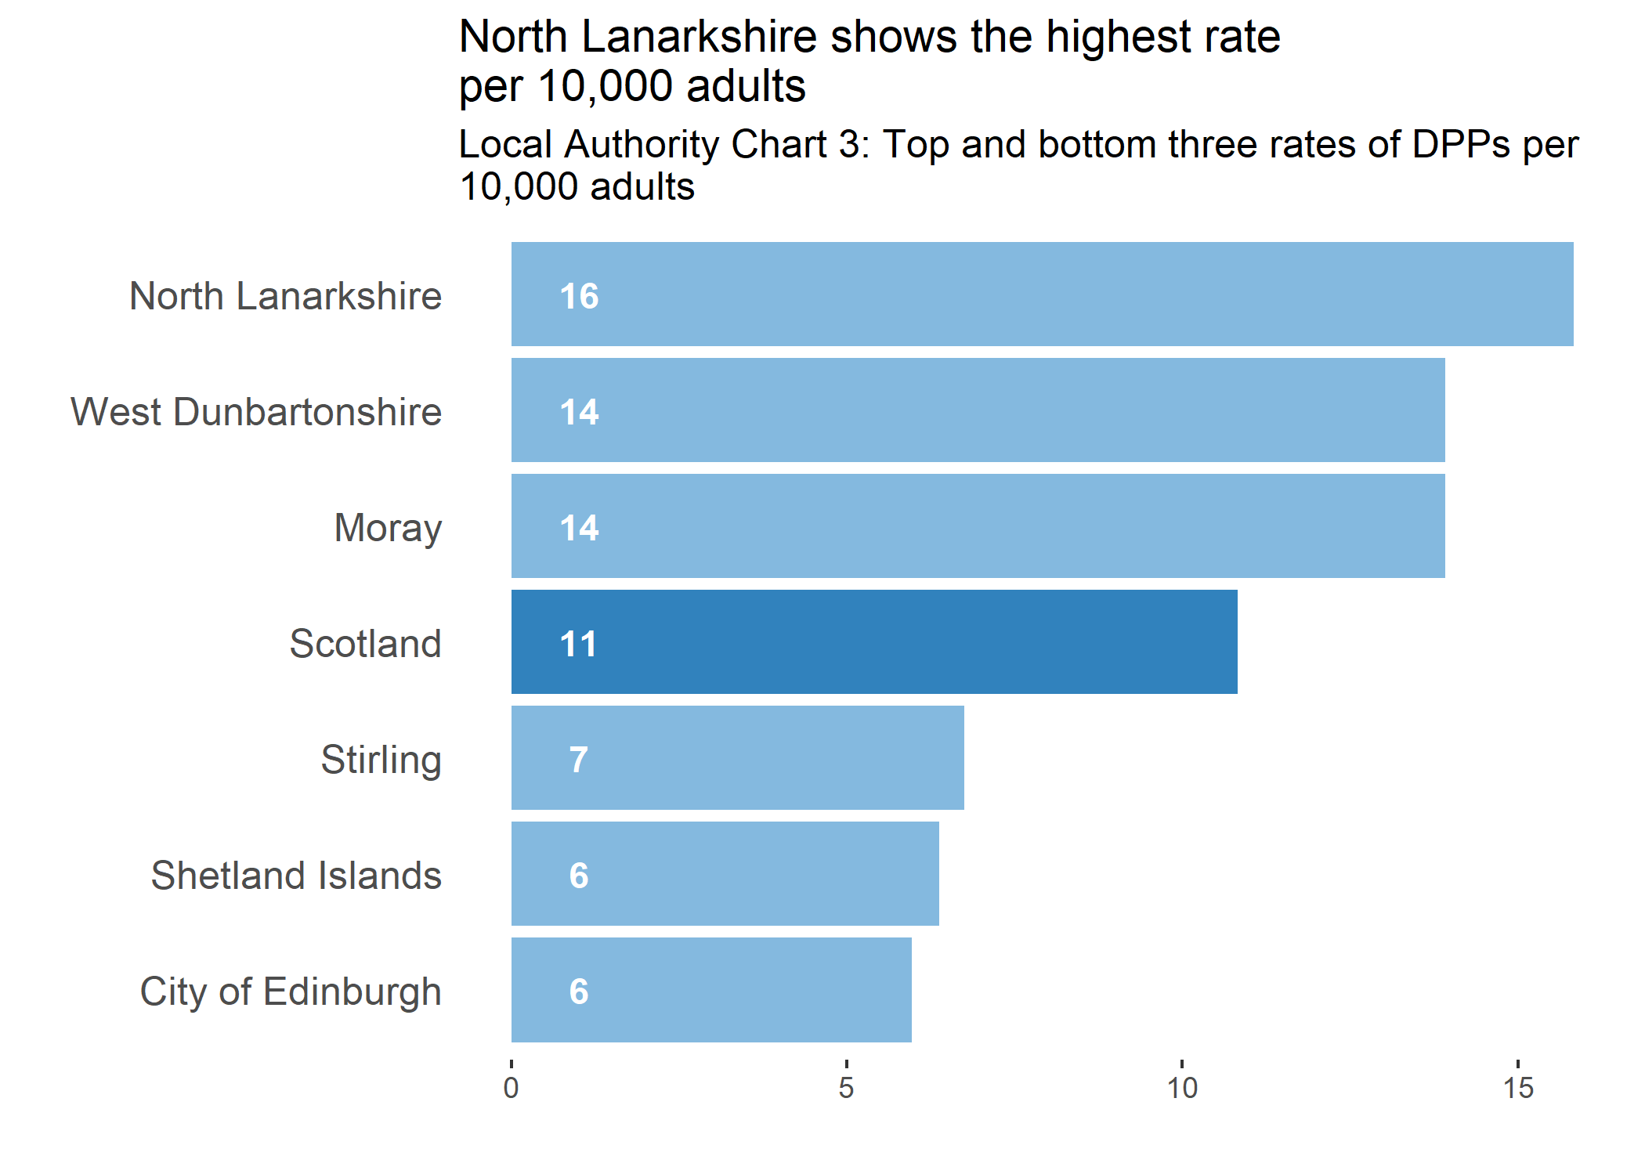

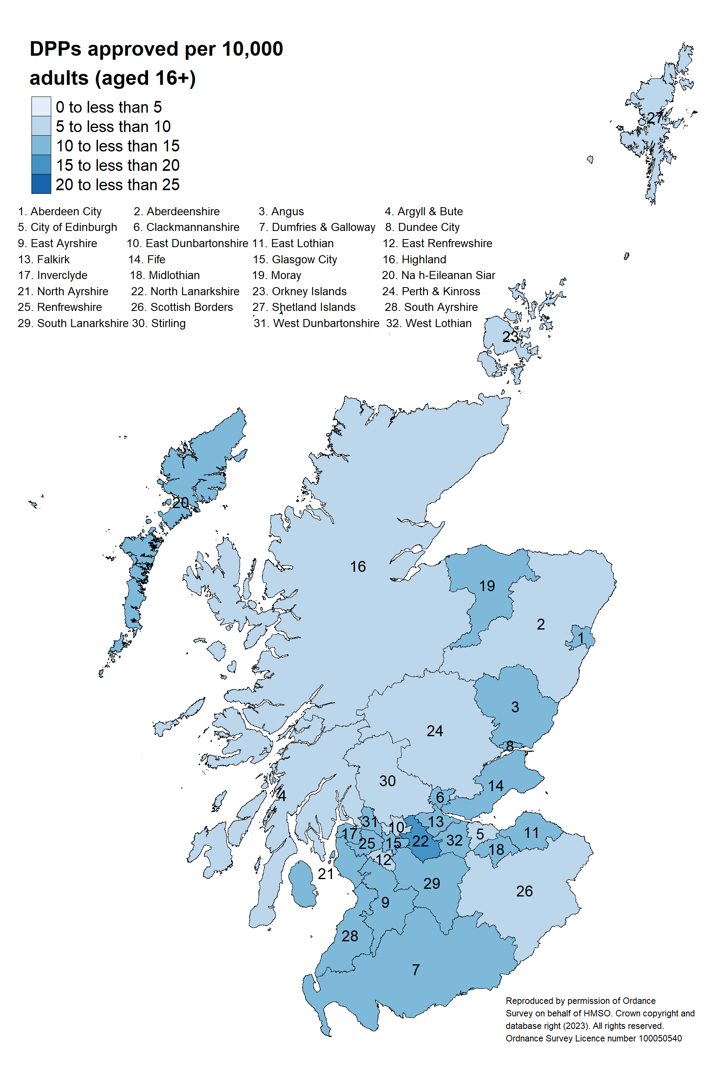

Outcome of DPPs
Since DAS was introduced, just over 46,800 DAS DPPs have been approved. Looking at each DAS case it can be established whether it has been completed, revoked or remains live and ongoing.
Table 9 below shows the outcome status for DAS cases by financial year of the approval date as at 31 March 2023. It should be noted that around 35.7% of DAS cases are still ongoing and a DPP approved in the last three financial years is expected to last for between 6.5 and 7.1 years. Consequently these figures need to be interpreted with caution.
Note that figures presented in Table 9 are not consistent with the official, headline statistics. This is because these figures are based on data extracted from the live DAS database at a different point in time. Furthermore, all DPPs approved in earlier years are mainly affected by missing information due to AiB’s data retention and destruction policy. For example, all information for revoked cases must be removed from the system two years after the date of revocation, and all information for completed cases must be removed three years after the date of completion.

Table 9: Number of DPPs by outcome, duration and length of survival
Financial year of the approval date | 2015-16 | 2016-17 | 2017-18 | 2018-19 | 2019-20 | 2020-21 | 2021-22 | 2022-23 | Annual change (%)
Median expected duration for live DPPs (years) | 9.8 | 9.3 | 8.5 | 8.1 | 7.4 | 7.1 | 6.5 | 6.5 | [z]
Median actual duration for completed DPPs (years) | 4.2 | 3.9 | 3.3 | 2.9 | 2.3 | 1.6 | 1.0 | 0.3 | [z]
Median actual duration for revoked DPPs (years) | 1.9 | 1.9 | 1.6 | 1.8 | 1.7 | 1.2 | 0.7 | 0.4 | [z]
Number of approved DPPs | 2,043 | 2,233 | 2,318 | 2,544 | 3,130 | 3,677 | 4,489 | 4,947 | 10.2%
of which: Balancing item to match the published statistics | 1 | 2 | 4 | 1 | 0 | 0 | 0 | 0 | [z]
of which outcome: Live as at 31 March 2023 | 362 | 614 | 844 | 1,210 | 1,866 | 2,517 | 3,453 | 4,705 | [z]
of which outcome: Completed as at 31 March 2023 | 807 | 794 | 668 | 535 | 460 | 294 | 114 | 18 | [z]
of which outcome: Revoked as at 31 March 2023 | 873 | 823 | 802 | 798 | 804 | 866 | 922 | 224 | [z]
of which: Survived for one year | 1,715 | 1,937 | 1,936 | 2,230 | 2,907 | 3,316 | 3,783 | [z] | [z]
of which: Survived for two years | 1,482 | 1,696 | 1,732 | 2,068 | 2,624 | 2,893 | [z] | [z] | [z]
of which: Survived for three years | 1,342 | 1,568 | 1,658 | 1,921 | 2,385 | [z] | [z] | [z] | [z]
of which: Survived for four years | 1,278 | 1,523 | 1,582 | 1,779 | [z] | [z] | [z] | [z] | [z]
of which: Survived for five years | 1,246 | 1,465 | 1,522 | [z] | [z] | [z] | [z] | [z] | [z]
of which: Remains survived so far | 1,169 | 1,408 | 1,512 | 1,745 | 2,326 | 2,811 | 3,567 | 4,723 | [z]
Source: Accountant in Bankruptcy

Table 9 above also shows the length of survival of approved DAS cases by financial year of the approval date since 2015-16. The five-year survival rate for all DAS cases approved in 2017-18 which either remained live or became completed successfully in 2022-23 was around 65.7%.
Chart 6 below shows the percentage of DAS cases approved resulting in revocation within one to three years of the approval date.
In 2022-23, the one-year DAS revocation rate fell below the rate for all earlier years (up to 2015-16). It is important to note that this one-year DAS revocation rate for 2022-23 (fixed as at 31 March 2023) may increase in the next financial year because cases approved in late 2022-23 may result in revocation in 2022-23 and statistics on 2023-24 are not included in this annual report. For example, in the previous annual report, the one-year DAS revocation rate was 6.5% as at 31 March 2022. This has been revised upwards to 15.7%.

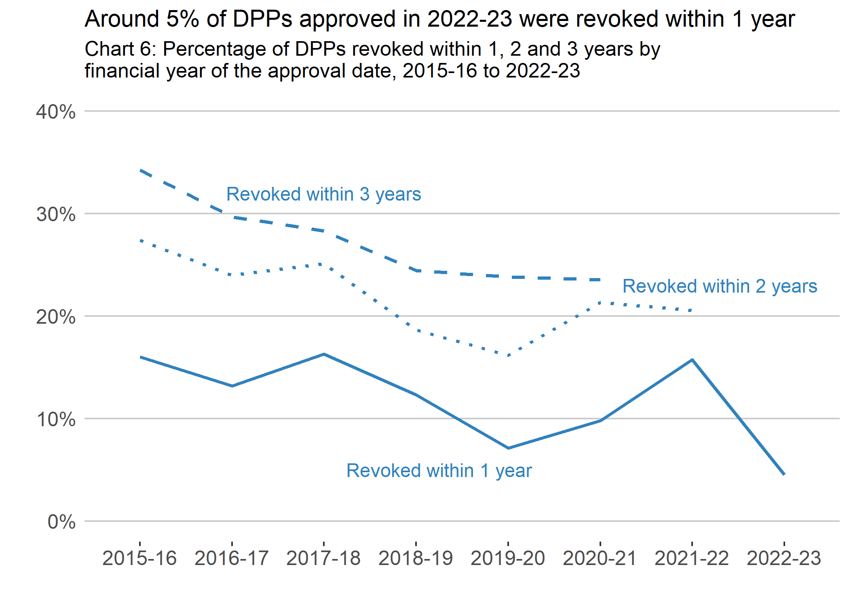

Corporate Insolvency
AiB is responsible for devolved elements of corporate insolvency, including: development of policy on liquidation and receivership, and the management and maintainence of the Register of Insolvencies.
The Register of Insolvencies contains details of liquidation and receivership of Scottish businesses which are wound up by either a Sheriff Court or the Court of Session. AiB is required to be notified of all company liquidations and receiverships in Scotland.
Reserved elements remain the responsibility of the UK Government and are dealt with by The Insolvency Service, an executive agency sponsored by the Department for Business, Energy & Industrial Strategy. Reserved elements include: company voluntary arrangements, administration, legal effects of liquidation and regulation of insolvency practitioners. Statistics on these reserved elements are available from The Insolvency Service.
It is important to note that the statistics for corporate insolvencies and members’ voluntary liquidations presented below are based on the date either process was registered on AiB’s administrative system. As a consequence, there is a time lag between the dates when a corporate insolvency is awarded or a member voluntary liquidation is registered and when AiB receives notice.
Corporate insolvency statistics presented here may differ from equivalent statistics published by The Insolvency Service, who source their data from Companies House. Similarly, members’ voluntary liquidations presented here may differ from equivalent statistics published by Companies House.
With this caveat in mind, there were 1,132 corporate insolvencies in 2022-23, 278 more than in 2021-22. Corporate insolvencies include receivership appointments, compulsory liquidations and creditors’ voluntary liquidations, this breakdown is detailed in Table 10 below. Historically, the volume of corporate insolvencies in Scotland have been driven by compulsory liquidations. Since 2020-21, this has not been the case.

Financial year of the receipt date | 2015-16 | 2016-17 | 2017-18 | 2018-19 | 2019-20 | 2020-21 | 2021-22 | 2022-23 | Annual change (%)
Number of corporate insolvencies | 902 | 846 | 884 | 967 | 948 | 442 | 854 | 1,132 | 32.6%
of which: Receiverships | 4 | 5 | 1 | 3 | 1 | 0 | 0 | 0 | [z]
of which: Compulsory liquidations | 596 | 558 | 548 | 601 | 618 | 172 | 154 | 340 | 120.8%
of which: Creditors' voluntary liquidations | 302 | 283 | 335 | 363 | 329 | 270 | 700 | 792 | 13.1%
Members' voluntary liquidations | 810 | 597 | 533 | 507 | 705 | 879 | 717 | 632 | -11.9%
Source: Accountant in Bankruptcy

In 2022-23, AiB also recorded 632 members’ voluntary liquidations compared with 717 in 2021-22. Members’ voluntary liquidations are not a form of insolvency.
Chart 7 shows the levels of corporate insolvency compared with members’ volutary liquidations.

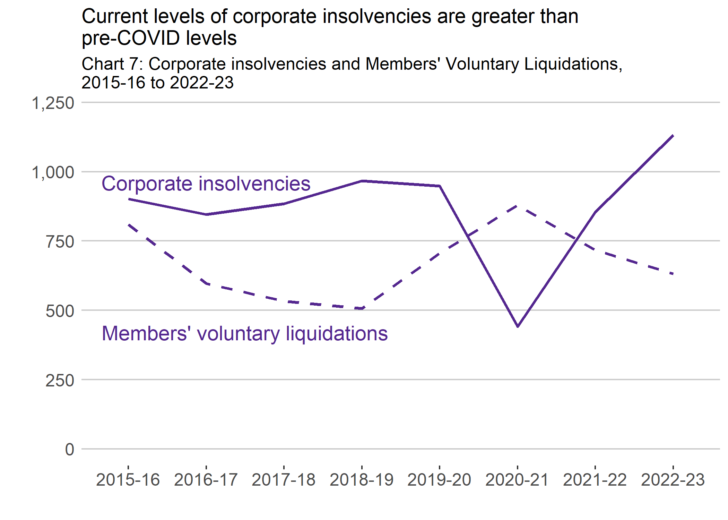
AiB does not publish statistics on the number of company voluntary arrangements or administrations, which are a reserved matter for the UK Government. These statistics are available from The Insolvency Service.

Average debt level by type of debt solutions
Table 11 below shows the median (average) debt level by financial year and type of debt solution. In 2022-23, the debt of a typical petition, MAP, full administration, PTD, and DAS respectively is £14,900, £12,000, £30,600, £16,400 and £13,200. The debt level for each debt solution remains fairly stable over time since 2015-16, with the exception of petitions where the minimum debt level was raised to £10,000 under the Coronavirus (Scotland) (No. 2) Act 2020 which came into force on 27 May 2020. This minimum debt level was then permanently set at £5,000 on 01 October 2022 through the Coronavirus (Recovery and Reform) (Scotland) Act.

Financial year of the awarded/protected/approved date | 2015-16 | 2016-17 | 2017-18 | 2018-19 | 2019-20 | 2020-21 | 2021-22 | 2022-23 | Annual change (%)
Bankruptcy: Creditor petition (£) | [x] | [x] | [x] | 10,100 | 11,400 | 10,000 | 17,500 | 14,900 | -14.9%
Bankruptcy: Minimal Asset Process (£) | 9,300 | 9,000 | 9,300 | 9,600 | 9,600 | 11,200 | 11,700 | 12,000 | 2.6%
Bankruptcy: Full Administration (£) | 25,100 | 26,800 | 26,000 | 25,700 | 25,000 | 30,900 | 30,300 | 30,600 | 1.0%
Protected trust deed (£) | 14,900 | 14,100 | 14,500 | 14,900 | 15,400 | 16,600 | 15,700 | 16,400 | 4.5%
Debt Arrangement Scheme (£) | [x] | 14,900 | 15,300 | 16,400 | 16,400 | 13,800 | 11,700 | 13,200 | 12.8%
Source: Accountant in Bankruptcy

Debt figures for all debtors have a very skewed distribution, with a long right-hand tail of high-level debts. In other words, the majority of debtors tend to have low- or medium-level debts while there are a few people with high-level debts.
The median is calculated by identifying the exact middle point in a set of all debts. So, when the debts are ranked from lowest to highest, the median is the value in the exact middle of the observed debts.
The median is AiB’s preferred measure of average debt level as it is less affected by a relatively small number of debtors with very high debt level than the mean is.
The mean is the sum of all debts divided by the number of debtors. Although mean figures are not presented here, these are similar to the median figures for each grouped debt level except for the debt level at least £10,000. In the latter grouped debt level (at least £10,000), the mean figure is much greater than the median figure because there is no upper limit.
It may help to distinguish between “average debt” (mean) and “the debt of a typical debtor” (median).

Average contribution level by type of debt solutions
Chart 8 below shows the median monthly contribution (payment) level by financial year and type of debt solution. In the last five financial years, the median monthly contributions in DPPs (between £160 and £220) have been greater than in PTDs (£140).
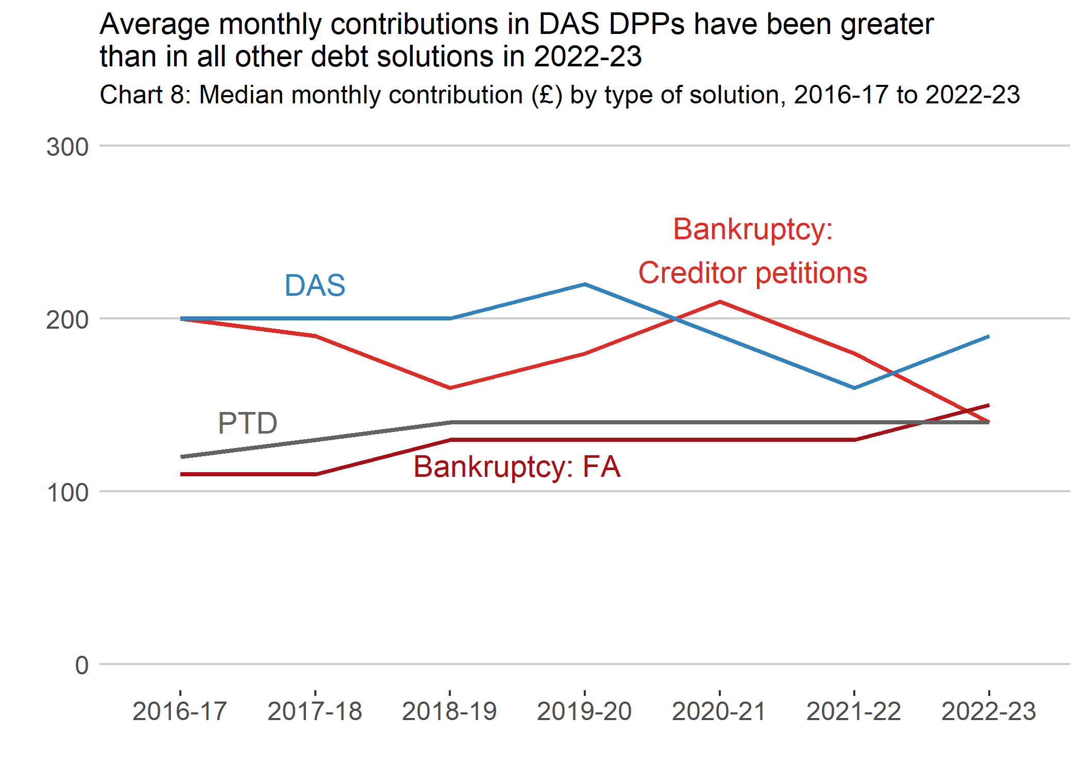

Background information

Data Sources
The statistics for Scottish statutory debt solutions (bankruptcies, PTDs, and DAS) are derived from administrative data of records processed within AiB and stored on the systems BASYS, ASTRA and eDEN (formerly DASH) respectively. Note DASH was decommissioned on 30 June 2019 and its replacement system, eDEN, went live on 1 July 2019.
The exception to this is creditor and trustee petition bankruptcies which are sourced from the courts that grant them and subsequently stored on the BASYS system.
The statistics for statutory moratorium on diligence are also derived from administrative data of records processed within AiB and stored on the Register of Insolvencies.
Corporate insolvencies are derived from administrative records provided by the courts and insolvency professionals (liquidators and receivers). Note that corporate insolvency statistics published by AiB may differ from equivalent statistics from the UK Government, through The Insolvency Service, as their data is sourced from their own administrative systems and Companies House. There is a time lag between the dates when a corporate insolvency is awarded or a member voluntary liquidation is registered and when AiB receives notice. Differences between sets of these statistics are mainly due to AiB using its own administrative system’s data.

Methodology
Figures are produced from tabulation of raw data from relevant administrative systems for bankruptcies, PTDs, DPPs under DAS, statutory moratoria on diligence and corporate insolvencies.
The numbers of personal insolvencies reported are based on the date of the court order, agreement of the insolvency procedure or approval date.
For creditor petitions, the published figures will be influenced by, for example, the late reporting of court orders which may lead to underestimating the number of creditor petitions awarded. Creditor petitions statistics are subsequently adjusted after the final quarterly release of the financial year. The revised figures are reflected in the next annual report of the financial year and the first quarterly report of the next financial year.
The number of DPPs under DAS reported are based on the date the DPP was approved. The number of statutory moratorium on diligence reported are based on the date the granted moratorium was submitted. Corporate insolvencies are based on the date the insolvency was registered in AiB’s administrative recording system.

General Revisions and Corrections
With the exception of statistics already reported in the quarterly Scottish Statutory Debt Solutions Statistics publications, figures presented in this Excel file for all financial years remain provisional and subject to revision.
Sometimes when quality assuring the data for the latest years, errors in data classifications applied to any type of statutory debt solutions, statutory moratorium on diligence, or any type of corporate insolvency may come to light. In this case, we may correct the erroneous data classifications in previous year and we will alert users of our statistics about such corrections.

Quality

Relevance
Relevance is the degree to which statistics meet the current and potential needs of user.
The statistics produced by AiB are the most complete record of the number of statutory debt solutions and statutory moratoria on diligence. Statistics on corporate insolvencies are also included.
The statistics presented here do not include non-statutory debt solutions. This is where debtors make their own arrangements with creditors or enter informal debt management plans with a debt management firm. The demand for statutory debt solutions should be seen within the context of the overall debt solution market (both statutory and non-statutory solutions).
This demand will be affected by changes in the legislative and regulatory environment. For example, changes to the Financial Conduct Authority’s regulatory procedures could affect the supply of non-statutory solutions and in turn the demand for statutory debt solutions.
Key users of AiB’s insolvency statistics are: AiB itself, which has policy responsibility for statutory debt solutions in Scotland and devolved areas of corporate insolvency; the insolvency profession; debt advice agencies; media organisations; academics; creditors and the general public.

Accuracy
Accuracy is the closeness between an estimated result and the (unknown) true value.
All formal insolvency procedures entered into by a company, a partnership or an individual are required by law to be reported to the appropriate body, so the statistics should be a complete record of statutory insolvency in Scotland.
The number of statutory debt solutions and statutory moratoria on diligence are based on the date of the order, agreement of the insolvency procedure or the approval date, not on the date it was registered on the administrative recording system. This does not have any implications for cases processed within AiB. However, the published number of creditor petitions will be influenced by, for example, the late reporting of creditor petition court orders, which may lead to missing data. Under the current revision policy, figures on the number of creditor petitions are revised quarterly to account for late reporting or missing cases.
The number of corporate insolvencies is based on the date the insolvency was registered on the AiB corporate insolvency recording system (BASYS). The corporate insolvency figures will be influenced by, for example, the late reporting of orders which may lead to a quarter’s figures containing cases awarded in the previous quarter. This should be noted when making comparisons of trends over time or comparing with other sources of data published by The Insolvency Service, and Companies House.
Data validation processes are in place to identify and resolve erroneous data inputs and duplication of cases or when extracting data from the administrative systems, to make sure that returns cover all debt solutions, and to check the accuracy and consistency within tables and between related tables.

Timeliness and punctuality
Timeliness refers to the time gap between the publication date and the reference period for the statistics.
Punctuality is the time lag between the actual and planned dates of publication for the statistics.
The Scottish Statutory Debt Solutions Annual Statistics are expected to be published on the first Wednesday of August following the end of the financial year being reported on. This publication date allows receipt of all the data inputs and sufficient time for quality assurance of the data extracts, tabulating records and completing the compilation of the statistical release. This means there is an approximate three month lag between the end of the financial quarter and the publication of the Scottish Statutory Debt Solutions Annual Statistics.
The exact publication date will be pre-announced through a 12-month release calendar, giving a specific release date at least four weeks in advance where practical – Official statistics: forthcoming publications - gov.scot

Accessibility and clarity
Accessibility is the ease with which users can access the statistics and data. It is also about the format in which data is available and the availability of supporting information.*
Clarity refers to the quality and sufficiency of the commentary, illustrations, accompanying advice and technical details.
The Scottish Statutory Debt Solutions Annual Statistics are available free of charge to the end user on the AiB website. They are published as HTML and a Word document via the website and ScotStat. The accompanying tables are also published in the Excel format. Contact details can be found at the beginning of our publication report for any specific data requests.
It is important to ensure that statistics are presented in a clear, unambiguous way that supports and promotes use by all types of users. To this end, we have adopted the use of plain language as much as possible. The main findings are presented using a series of text and charts. Technical terms, acronyms and definitions are defined and explained when this is appropriate. These approaches would ensure that the statistics can be used effectively.
However, AiB does want readers’ and users’ feedback on any aspect of these statistics, and encourage them to complete our online survey or get in touch with us. Contact details and link to the online survey can be found at the beginning of our publication report.

Comparability
Comparability is the degree to which statistics can be compared over time, region or another domain.
Statutory debt solutions statistics can be compared between different type of debt solutions. They can be used to identify trends over time.
However, changes in legislation and policy may affect the extent to which comparisons can be made over time for individual data series. Such change might cause breaks in time series so that statistics from before and after the change are not comparable. Where such changes are known, they have been highlighted in the commentary and in the general background notes along with the implications for use made clear.

Coherence
Coherence is the degree to which the statistical processes that generate two or more outputs use the same concepts and harmonised methods.
Overall, the Scottish Statutory Debt Solutions Statistics are the definitive source of statistics for statutory debt solutions in Scotland. The Insolvency Service include figures from the Scottish Statutory Debt Solutions Quarterly Statistics publications in their official statistics releases on individual insolvencies - Individual Insolvency Statistics Releases - GOV.UK
It is important to note that the operational, policy and legislative differences in all nations of UK, and users should be mindful of this caveat when making comparisons with other parts of the UK.
AiB publishes year end totals of the quarterly statistics in this annual publication. These numbers may differ slightly to those reported throughout the year, but the annual statistics are subsequently revised to match. In these annual publications, statistics by local authority areas are included and this is achieved by matching the postcode with the Standard Geography Code Register: statistics.gov.scot : Standard Geography Code Register. This Register contains the standard statistical blocks which are Output Areas, Data Zones and Intermediate Zones, and these blocks are derived from Scotland’s 2011 Census geographies. Adopting the standard geography code ensures geographical harmonisation and coherence, enabling the data to be consistent over time between local authority areas within Scotland. Note, when producing statistics by local authority areas, numbers may differ slightly as postcodes of debtors cannot always be assigned, where this occurs these differences will be highlighted.
Overall, the annual experimental and quarterly official statistics are the definitive source of statistics for statutory debt solutions in Scotland.
AiB is required to be notified of all company liquidations and receiverships in Scotland, and publishes quarterly official statistics based on its own administrative records. These differ from the Insolvency Service’s Insolvency Statistics publications, which use data from Companies House as the source. Differences are due to AiB using its own administrative system’s data rather than the start date of the insolvency.

Statutory Debt Solutions legislation

Insolvency legislation

Personal Insolvency
The Accountant in Bankruptcy (AiB) has a duty to supervise all personal insolvencies in Scotland. It also administers those bankruptcies where The Accountant acts as trustee.
There is legislation for all three statutory debt solutions in Scotland as well as the duties and functions of the AiB. The statute relating to personal insolvency is within the Bankruptcy (Scotland) Act 2016 (“the 2016 Act”) and associated regulations.
Bankruptcy legislation has evolved over many years. The Bankruptcy and Diligence Act 2007 introduced reforms from 2008 introduced:
- self-nominated bankruptcy by application to AiB and;
- a new access route through Low Income Low Asset (LILA) bankruptcy.
This streamlined the bankruptcy process for individuals on low income and with very few assets. The Bankruptcy and Debt Advice (Scotland) Act 2014 (“BADA(S)”) replaced LILA with Minimal Asset Process (MAP) bankruptcy. This took effect from 1 April 2015 and introduced more flexible entry criteria and a lower application fee.
BADA(S) introduced the need for money advice before self-nominated bankruptcy. This placed advice as an essential part of all statutory debt solutions in Scotland. The 2016 Act simplified and consolidated previous statutes into one piece of legislation. This included the main statutory provisions for Protected Trust Deeds in primary legislation. Before, most of this was in secondary legislation through the Protected Trust Deeds (Scotland) Regulations 2013.

Corporate Insolvency
The Insolvency Act 1986 is the primary legislation covering UK Corporate Insolvency. There is secondary legislation which applies only in Scotland. They are:
- the Insolvency (Scotland) (Receivership and Winding Up) Rules 2018 and;
- the Insolvency (Scotland) (Company Voluntary Arrangement and Administration) Rules 2018.
These rules replaced the Insolvency (Scotland) Rules 1986. AiB receives, extracts and records information from documents about company liquidations and receiverships.

Debt Arrangement Scheme legislation
AiB administers the Debt Arrangement Scheme (DAS). A Debt Payment Programme (DPP) under DAS allows individuals to repay debts over an extended period. It provides protection from creditor enforcement. It also safeguards assets including their home as long as mortgage payments are maintained.
A DPP under DAS can last for any period of time agreed by creditors or deemed fair and reasonable. If approved, it will freeze all interest, fees and charges on the debt included. This results in them being waived on successful completion of the programme.
DAS law is under the Debt Arrangement and Attachment (Scotland) Act 2002 and associated regulations - the Debt Arrangement Scheme (Scotland) Regulations 2011.
The Debt Arrangement Scheme (Scotland) Amendment Regulations 2019 came into force in November 2019. These introduced some important reforms and are the most recent DAS regulations. In particular, they removed any fees payable by a debtor for advice provision. They also introduced revised fee structures and arrangements for payments distribution to creditors.

Coronavirus Legislation
The Coronavirus (Scotland) Act 2020 and the Coronavirus (Scotland) (No. 2) Act 2020 were introduced by the Scottish Government. This was in response to the emergency situation caused by the COVID-19 pandemic. Both Acts included temporary measures which impact on insolvency legislation. This was deemed necessary to:
- strengthen debtor protections at that time;
- solve operational problems caused by the pandemic and;
- ensure the system was well-equipped to deal with any surge in demand caused by the pandemic.

Coronavirus (Scotland) Act 2020
This Act increased the length of the moratorium period from 6 weeks to 6 months. During a moratorium a debtor is protected from creditor debt enforcement. This gives debtors a chance to take advice and consider the best solution for problem debt.
The Act also temporarily allowed more than one moratorium in any 12 month period. This enabled access to protection for those that had a previous moratorium.

Coronavirus (Scotland) (No. 2) Act 2020
This Act made several temporary changes to bankruptcy legislation. Some of these changes focused on the operational aspect of bankruptcy. This was to ensure efficiency and flexibility in bankruptcy administration during the COVID-19 pandemic. These changes included:
- allowing the electronic signing and service of documents;
- increasing the deadline for submitting Debtor Contribution Order proposals and;
- allowing for virtual creditor meetings in bankruptcy.
The debt threshold for MAP bankruptcy eligibility increased from £17,000 to £25,000. Student loan debt was removed from contributing to this calculation. The Act provided lower cost access in debtor application bankruptcy. Debtor application costs for Full Administration reduced from £200 to £150. MAP application fees reduced from £90 to £50. Fees were removed for those in receipt of certain prescribed benefits.
The Act changed the eligibility criteria for a creditor to petition for sequestration. The amount of money owed to creditor(s) to be “qualified” to raise proceedings was increased from £3,000 to £10,000.

Expiry of Coronavirus Acts
The Bankruptcy (Miscellaneous Amendment) (Scotland) Regulations 2021 (the “2021 Regulations”) came into force in March 2021. These Regulations brought forward the expiry of some of measures in the Coronavirus (Scotland) (No.2) Act 2020 by replacing them with permanent provisions. The provisions aim to streamline the bankruptcy administration process. This improved access to MAP bankruptcy and reduced the cost of accessing bankruptcy.
In particular, these regulations amended the 2016 Act and associated regulations to:
- reduce all bankruptcy debtor application fees;
- remove application fees completely for those in receipt of certain prescribed benefits;
- increase the debt threshold for eligibility for MAP to £25,000
- remove student loan debt from the eligibility calculation;
- allow the electronic signature of bankruptcy forms;
- provide trustees twelve weeks to submit Debtor Contribution Order proposals.
The remaining provisions were extended until 30 September 2022.
The provision allowing more than one moratorium in any 12 month period was not extended. This measure expired on 30 September 2021. The original provision in the 2016 Act is now reinstated. Only one moratorium application is permitted within 12 months.

Coronavirus (Recovery and Reform) (Scotland) Act
The moratorium and bankruptcy parts of the Coronavirus (Recovery and Reform) (Scotland) Act commenced on 1 October 2022. These include:
- modernising provisions that enable electronic delivery of documents and;
- allowing remote meetings of creditors in bankruptcy proceedings.
The Act provides more protections for those dealing with problem debt. It amends the debt level creditor(s) must be owed to be “qualified” to raise proceedings to £5,000. The Act fixes the period of protection provided by the moratorium period at 6 months. Before the temporary provisions, the protection period was fixed at 6 weeks.

The Bankruptcy and Debt Arrangement Scheme (Miscellaneous Amendment) Regulations 2023
The Bankruptcy and Debt Arrangement Scheme (Miscellaneous Amendment) Regulations 2023 came into force on the 6 February 2023. The provisions included in the regulations were brought in to help with the current cost crisis.
Changes to bankruptcy legislation include:
- the removal of the minimum debt level to access Minimal Asset Process bankruptcy;
- the removal of application fee requirements for bankruptcy if the applicant is assess by the Common Financial Tool as having no surplus income;
- increases to the deposit paid by creditors from £300 to £750 where AiB is nominated as trustee in a creditor petition bankruptcy.
For the Debt Arrangement Scheme, measures amended the payment break process so that an application could be made where there was a 50% reduction in disposable income where it is considered that the reduction will last for the period of the break, and the circumstances previously required for a payment break were removed.

Glossary
Term | Definition
Apparent Insolvency (AI) | A legal term that means you are unable to pay your debts and that at least one of your creditors has taken legal action against you.
Bankruptcy | Formal court process which transfers your property to a trustee.
Certificate for Sequestration | The Certificate for Sequestration is issued to a debtor by a Money Adviser or Insolvency Practitioner and serves as written proof of their insolvency and qualification for bankruptcy.
Compulsory liquidation | Compulsory liquidation (or winding up by the court) is a procedure by which the assets of a company are sold, and the proceeds are distributed to the company's creditors. A court order is required to put a company into compulsory liquidation.
Creditor | Any person, business or organisation which is owed money by another.
Creditor petitions | When a creditor who is trying to recoup monies owed to them petitions to have the debtor made bankrupt.
Creditors' voluntary liquidations | A director can propose a creditors’ voluntary liquidation if the company can’t pay its debts (it’s ‘insolvent’) or enough shareholders agree. This means the company will stop trading and be liquidated (‘wound up’).
Debt Arrangement Scheme (DAS) | A debt management tool introduced by the Scottish Government and accessed through an approved money advisor. It may help you if you have one or more debts and want to pay what you owe by giving more time for repayments free from the threat of enforcement (diligence) or bankruptcy.
DAS Debt Payment Programme (DPP) | A proposal that allows a debtor to pay their debt over an extended period of time. The DPP can be for any amount of money or for any reasonable length of time.
Debtor | Any person who owes money to another.
Debtor applications | When individuals apply for their own bankruptcy.
Insolvency | Insolvency occurs when an individual or a firm is unable to meet its financial obligations.
Insolvency Practitioner | A person (usually, but not necessarily, a chartered accountant) licensed and authorised to act as a trustee in sequestrations or trust deeds and also as liquidator, administrator, or receiver of a limited company.
Full Administration | A route into bankruptcy, if conditions set out in MAP are not met. Conditions for Full Administration are if a person's debts are over £3,000, or own assets valuing £2,000 or more.
Low Income Low Asset (LILA) | LILA was the route into bankruptcy introduced to provide debt relief to debtors who cannot afford to pay their debts and have low income and limited assets. Many debtors find that their creditors are unwilling to take the legal action required to bring about their bankruptcy because of the administrative and legal costs incurred, often without the creditor receiving any dividend at the end.LILA was replaced by the MAP route into bankruptcy in 2015.
Minimal Asset Process (MAP) | A route into bankruptcy for people on low income who do not own property and have very little in savings or other assets. This is known as Minimal Asset Process (MAP) and replaced the LILA route into bankruptcy. A debtor will be discharged after six months, if they continue to meet the MAP criteria, (cases will be converted to Full Administration where it is found that debtor’s do not meet MAP criteria).
Members' Voluntary Liquidation | The shareholders of a solvent company adopt a voluntary winding up resolution and appoint a liquidator to realise the assets of the business in order to distribute the proceeds to company members. A company is considered legally solvent when it is able to meet its financial obligations and the value of its assets.
Money adviser | Somebody trained to offer advice on debt usually at at local authority money advice unit or Citzens Advice Bureau.
Moratorium on diligence | A protection from creditor debt enforcement. This protection is available to individuals as well as certain entities. Although it is normally lasts for a period of six weeks, the Coronavirus (Scotland) Act has been enacted to extend the duration of the moratorium to six months temporarily due to the current COVID-19 pandemic. Under normal circumstances, a moratorium cannot be granted more than once in any 12-month period. However, this rule has been set aside temporarily as a result of the aforementioned emergency legislation.
Personal insolvencies | The sum of awards of bankruptcy (Full Administration and MAP) and PTDs.
Protected trust deed (PTD) | A trust deed is a form of insolvency that transfers your estate to a trustee to be realised for the benefit of creditors. A trust deed may be protected as long as a majority in number or a third in value of creditors do not object to its terms. Once protected, the terms of the trust deed becoming binding on all the creditors.
Rate per 10,000 adults | Rate per 10,000 adults (aged 16+) is the specific number of statutory debt solution divided by the number of people aged 16 or over, multiplied by 10,000. A rate of a 100 per 10,000 adults is equivalent to 1% of the adult population.
Receivership | A receiver is appointed by a lender holding a charge over some or all of the company's assets. The main responsibilities of a receiver are to ensure the appointing lender is paid off. The law recognises that the receiver's control over the company can have considerable effect on the company and its other creditors.
Trustee | Person who administers your bankruptcy or trust deed. In sequestrations your trustee can be either the Accountant in Bankruptcy or a private insolvency practitioner (normally a chartered accountant who specialises in personal bankruptcy). In trust deeds, trustees must be an insolvency practitioner.

An Experimental Statistics publication for Scotland
The figures released today are classed as Experimental Statistics though these were produced in accordance with professional standards set out in the Code of Practice for Official Statistics; they undergo regular quality assurance reviews to ensure that they meet customer needs.

Correspondence and enquiries
For enquiries about this publication please contact:
AiB Statistics Team, Accountant in Bankruptcy
Email: aib_statistics@gov.scot
For general enquiries about Scottish Government statistics please contact:
Office of the Chief Statistician
Telephone: 0131 244 0442
Email: statistics.enquiries@gov.scot

How to access background or source data
The data collected for this statistical bulletin are available on the AiB Statistics webpages at https://www.aib.gov.uk/about-aib/statistics-data/quarterly-statistics.
Details of bankruptcies, PTDs, liquidations and receiverships can be found on the Register of Insolvencies, which is maintained by Accountant in Bankruptcy and can be accessed at: https://roi.aib.gov.uk/roi/.
The DAS register is an online public register which holds information about those who have a DPP under DAS, available at: https://eden.aib.gov.uk/dasregister.

Complaints and suggestions
If you are not satisfied with our service or have any comments or suggestions, please write to:
The Chief Statistician, 2W, St Andrews House, Edinburgh, EH1 3DG
Telephone: (0131) 244 0302
Email: statistics.enquiries@gov.scot
If you would like to be consulted about statistical collections or receive notification of publications, please register your interest at: https://blogs.gov.scot/statistics/
Details of forthcoming publications can be found at: Official statistics: forthcoming publications - gov.scot

Crown Copyright
You may use or reuse this information (not including logos) free of charge in any format or medium, under the terms of the Open Government Licence. See: http://www.nationalarchives.gov.uk/doc/open-government-licence/version/3/

