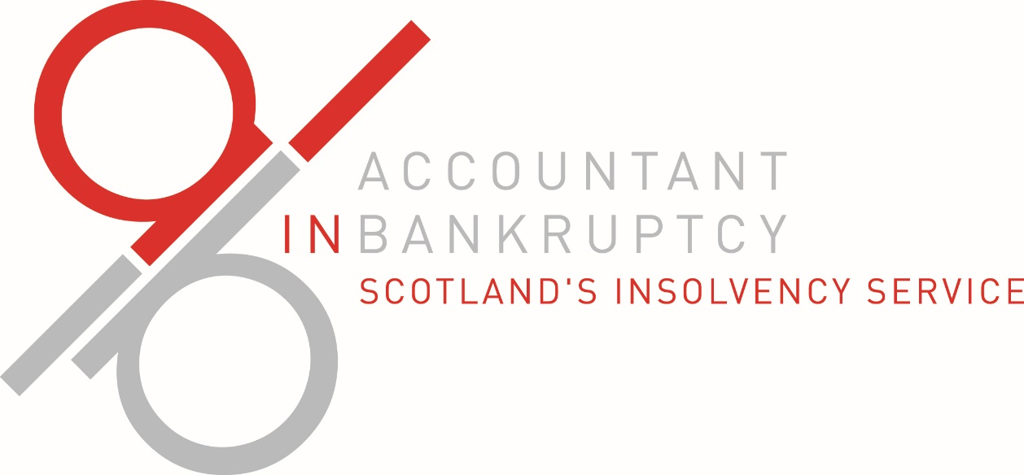

**Business Plan**

**2023-2024**

Contents page

Foreword 3

How AiB will deliver in 2023-24 5

Our Core Business 7

Key Performance Indicators 8

Finance: AiB 2023-24 income, budget and resource 9

AiB 2023-24 Business Objectives 12

Contact AiB 18

# Foreword

By Richard Dennis

The Accountant in Bankruptcy and Agency Chief Executive

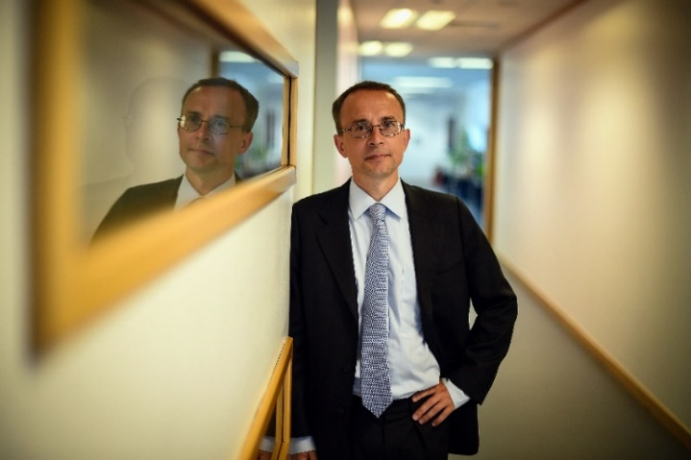

Our core business has remained essentially the same since the coming into force of the last set of major reforms in 2015. It is therefore remarkable how much change has happened over the last twelve months, and how much is planned for the coming year - as we drive to provide a better service, more responsive to what our customers want, and using public money more effectively.

Doing so relies on both those inside and those outside the organization. We need those outside to help us keep in close touch with the real world lives of those we exist to help – as the cost crisis and ongoing pandemic recovery place families and households under ever greater pressure. And as a small organization, we need our staff to be multi-talented, and flexible to use their skills wherever in the Agency they are needed. In return, we try to make the Agency a truly great place to work.

This plan adopts a rather different approach to previous years, reflecting the Board’s desire that we make our continuous improvement agenda more transparent and more measurable. It therefore focusses on six significant changes we will deliver over the coming year alongside keeping track of the ongoing business.

If we succeed in delivering all six changes and maintain our strong record of delivering our KPIs that track the casework that is our reason for being, then the Agency will be in a stronger place to face whatever challenges are coming next. I have every confidence that the team we have assembled here will be able to rise to those demands in future as they have done in the past.

Richard Dennis signature

Dr Richard Dennis

The Accountant in Bankruptcy and Agency Chief Executive

June 2023

## How AiB will deliver in 2023-24

The Agency exists to deliver the casework and regulation of Scotland’s statutory debt relief and debt management products, including the moratorium, bankruptcy, the debt arrangement scheme and protected trust deeds, and the related public registers. Most of our effort in the coming year will remain on delivering these efficiently and effectively, meeting our customers needs as best we can, and ensuring the Agency has the support and the resources necessary to keep on doing so. We aim to improve our performance in doing this across the year, by taking the actions set out under our core business objectives. We will also drive improvement by taking the following actions specific to this year:

### Moving our IT to the Cloud

This will deliver greater resilience and faster system performance to users inside and outside the Agency as well as allowing AiB to act as a pathfinder for SG colleagues as all departments move away from physical hosting.

### Implementing new legislation

A new Bankruptcy and Diligence Bill including taking powers to introduce a mental health moratorium was introduced to Parliament in late April, which will be followed by a number of sets of regulations taking forward proposals from last year’s stakeholder working groups. We will carry out the significant development work on our processes and IT systems to prepare for these coming into force.

### Telephony

We will implement a new telephony system allowing colleagues to respond to calls regardless of location - replacing the reliance on traditional desk phones with a system based on use of our laptop computers.

### Paperless Office

We will move further towards a digital first approach, increasing efficiency alongside reducing environmental impact. In the coming year, we will create a digital mailroom which will direct correspondence to appropriate work queues automatically, and exploit existing system functionality to reduce paper submissions and responses. This is expected to reduce our overall paper consumption by half from last year.

### Shared Service and IT System Development

The Agency relies on Scottish Government corporate systems for both HR information and financial management and reporting. The SG is replacing both these systems, with the scope for significant improvements in processes and provision of management information. We will integrate the new systems both with AiB’s own IT systems and our working practices to make best use of the new capabilities offered - with much preparatory work in advance of the target go live dates of Autumn 2023 (HR) and Spring 2024 (Finance).

We will enhance our eDEN case management system and refine supporting process after considering the results of a detailed business analysis of the current DAS function, allowing us to improve the user experience, bringing customer benefits including new annual statements showing progress towards debt freedom.

### Making best use of our Office Space

We will exploit the additional space freed up by our hybrid working model to provide more creative spaces and make our building a more effective and enjoyable working environment. We will create collaborative zones to allow teams more opportunity to work together to solve issues or discuss ways of improving processes. Meeting rooms and social meeting places will be refurbished to create a more relaxed environment.

Having done this, we will review our use of space to make sure teams sit alongside those with whom they work most closely – and we will replace the office lighting both to improve the office environment and to save energy.

**Our Core Business**

We will assess our progress on our core products by regular monitoring of the key performance indicators set out on the following pages. We will also conduct a customer satisfaction survey to assess how far the service we provide meets stakeholder requirements.

The work of AiB contributes to Scotland’s National Performance Framework viewable at [www.nationalperformance.gov.scot](http://www.nationalperformance.gov.scot)

Our detailed business objectives for 2023-24 (pages 11-17) explain what we will be doing in the next year to help deliver our strategy and support Scotland’s National Outcomes. These objectives also detail areas where we will address our social and environmental responsibilities through sustainability activities and changing service approaches.

We will report quarterly to our Board and via our Annual Report to the wider stakeholder community on both our key business indicators and our six key improvements for 2023-24.

To find out more about our mission, values and key functions visit our website [www.aib.gov.uk](http://www.aib.gov.uk)

# Key Performance Indicators

#### Case processing times

Bankruptcy target: 9 days

The time from when a self-nominated application is submitted and the fee received until a bankruptcy is awarded and published on the Register of Insolvencies.

DAS target: 4 days

The sum of **both**: the time from initial receipt of a Debt Payment Programme (DPP) until proposal letters are issued to creditors; **and** from the end of the creditor approval period until the DPP decision letters are issued.

PTD target: 1.5 days

The time taken from receipt by AiB of a Form 3 (which is the submission by the trustee of a trust deed for protection) until the protection or rejection of the trust deed.

**Administration cost per case**

To keep the average costs of case administration within the following limits:

* MAP – £139
* Bankruptcy - £213
* Debt Arrangement Scheme - £39

The cost KPIs exclude insolvency practitioner fees and case outlays which are dependent on case-specific circumstances. They also exclude all office overheads, including systems depreciation which are fixed regardless of case volumes.

We have discontinued a cost KPI for protected trust deeds given we are not a provider of protected trust deeds, and our role in their administration is therefore more limited than in the other products.

**Sustainability**

In 2023-24 AiB will set new annual targets and map our route to net zero by 2045.

# Finance: AiB 2023-24 income, budget and resource

## Table 1 – Draft Budget 2023-24

|  |  |
| --- | --- |
| Category | Draft budget 2023-24 (£000s) |
| Operational costs | 8,554 |
| Non-cash | 1,046 |
| Resource budget requirement | 9,600 |
| of which is funded by: operating income | 8,474 |
| of which is funded by: sg resource allocation (cash) | 80 |
| of which is funded by: sg resource allocation (non-cash) | 1,046 |
| Total funding | 9,600 |
| Capital budget requirement | 850 |
| of which is funded by: sg allocation (capital) | 850 |
| Overall budget requirement to be funded by sg allocation | 1,976 |

## 

## Table 2 – Budget requirements by category and percentage of total spend

|  |  |  |
| --- | --- | --- |
| **Category** | **Draft budget 2023/24 (£000s)** | **Percentage of budget** |
| Total operating expenditure | 8,554 | 91% |
| of which: Staff costs | 5,479 | 57% |
| of which: Direct sequestration costs | 1,924 | 20% |
| of which: Other operating costs | 1,151 | 12% |
| Non-cash expenditure | 1,046 | 11% |
| Total resource budget requirement | 9,600 | 100% |
| of which is funded by: Operating income | 8,474 | 88% |
| of which is funded by: SG resource allocation (cash) | 80 | 1% |
| of which is funded by: SG resource allocation (non-cash) | 1,046 | 11% |
| Total resource funding | 9,600 | 100% |
| Capital Programme | 850 | 100% |
| of which is funded by: SG Capital Allocation | 850 | 100% |

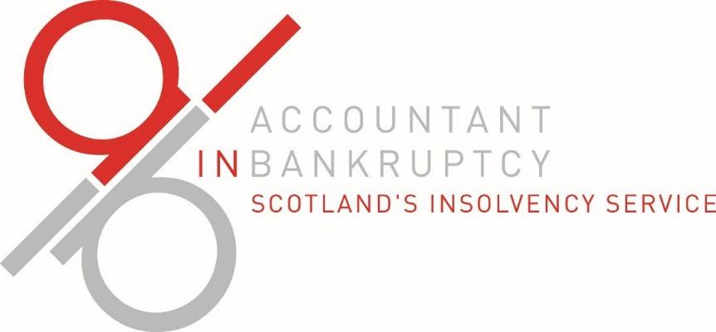

**Business**

**Objectives**

**2023-2024**

# AiB 2023-24 Business Objectives

## Objective 1 – Delivery of Core Products

**We will:**

* Undertake our duties, as specified in the relevant legislation, and in accordance with our agreed processes and policies in line with statutory timescales and key performance indicators.
* Monitor operational outputs continuously to ensure targets are achieved, producing reports to illustrate the state of play across branches.
* Take a proactive approach to managing staff resource, prioritising effort appropriately to prevent backlogs and keep outstanding work at manageable levels.
* Engage with our internal and external stakeholders to help make it easier for them to understand AiB’s systems, operational processes and requirements.
* Procure new external partners to contribute to the delivery of our key business activities. This includes procurement of:
  + Website Design, Build, Hosting & Support – tender out February 2023
  + Credit Reference Checking – award by June 2023
  + Sheriff Officers – award by February 2024
  + Chartered Surveyors – contract ends November 2023 with option to extend
  + Legal Agents – contract ends May 2024, AiB on UIG for next SG framework
  + Postal Service – award by September 2023

Other procurement activity to commence during the year includes Print, Design and Associated Services, Penetration Testing and Project Delivery training.

## Objective 2 – Continuous Improvement

**We will:**

* Continue to deliver a culture of hybrid learning to support our blended working strategy by providing access to blended learning activities for all staff including virtual, face-to-face, and digital learning.
* Complete the agreed programme of internal compliance checks to ensure business areas are operating in accordance with statutory requirements, that they are robust, fit for service and offer good value for money, and take forward any improvement opportunities found by these reviews.
* Review our purchase to pay process, our scheme of delegations and streamline our management information reports. Introduce new management accounts report layout from end of Q1 2023-24.
* Further develop AiB’s cyber resilience capability and heighten staff awareness of the threat presented by malicious actors using phishing emails.
* Create a digital mailroom to improve efficiency and accuracy of all mail received (electronic or physical).
* Commence a Cloud Services Project to transition AiB’s systems to the cloud.

## Objective 3 – Stakeholder Engagement

**We will:**

* Relaunch our series of Roadshows, allowing us to hear direct from key stakeholders about where they want us to focus on improving our systems and processes.
* Develop a new website, improving on the structure of the site and ensuring the content is targeted for its audience and wherever possible fully accessible. Contract start date June with a live launch planned for December 2023.
* Work within the local business community, through local schools and alongside North Ayrshire Chamber of Commerce to develop AiB’s Developing Young Workforce programme for 2023 and prepare for the 2024 Young Workforce Initiatives.
* Hold regular meetings of the Bankruptcy Stakeholder Group, the Common Financial Tool Working Group, the PTD Standing Committee and the DAS Working Group to discuss current issues and stakeholder concerns.
* Work with the Insolvency Service and the Regulated Professional Bodies, including on matters relating to the regulation of Insolvency Practitioners.
* Support the Ministerial Working Group on Statutory Debt Solutions and relevant short life working groups.
* Continue our Executive Directors’ involvement in the International Association of Insolvency Regulators, and other international fora, forging relationships for discussing best practice in insolvency regulation and service provision.
* Deliver training to empower individuals to challenge inappropriate behaviours in a safe and effective way.
* Take action based upon staff feedback drawn from the annual AiB people survey, IiP Report and monthly staff focus groups - including publishing an 2023-24 employee engagement plan based upon the results.
* Raise the profile of Procurement and Finance processes through running awareness sessions, reviewing intranet guidance and strengthening understanding of processes through offering job shadowing opportunities.

## Objective 4 – Agency Governance and Best Value

**We will:**

* Hold (quarterly) Board and Risk and Audit Committee meetings, providing the agreed papers to each meeting as set out in the relevant business schedules, and take forward all recommendations coming from these meetings.
* Maintain robust governance and finance frameworks to ensure agency funds are appropriately approved, spent and monitored including review of financial and purchasing authority limits. We will again aim to obtain an unqualified audit opinion from our external auditors, and action any recommendations from internal or external audit reports.
* Report to and meet with Ministers, the Parliament and our “Fraser Figure” (the Scottish Government senior official tasked with liaison with the Agency) as required.
* Continue to review our operational processes to ensure they remain complaint with the General Data Protection Regulation, Freedom of Information and Data Protection Act. Implement our new case management systems information retention and destruction processes and review and update as required, our records management systems.

Objective 5 – Environment and Social **We will:**

* Maintain a hybrid working model that allows AiB staff to work from multiple locations to increase collaboration, job satisfaction, and employee engagement, beneficial to both staff and the organisation.
* Continue to upskill our staff and develop succession planning, talent management, and resourcing to build a more engaged, motivated, and skilled workforce.
* Increase engagement with local corporate parents and publish a new three year corporate parenting plan.
* Continue supporting and recognising our staff needs by offering regular staff sessions and feedback forums. This will be evidenced through the Investors in People (IiP) programme, for which we aim to retain Gold status.
* Continue to offer health & wellbeing support to staff through the Health and Wellbeing group (formally known as Healthy Working Lives).
* Continue to support the Scottish Government 2045 target to achieve net-zero emissions by:
  + Reporting quarterly on sustainability to our Audit Committee and Advisory Board through the Agency’s Environmental and Biodiversity plan, setting out new sustainability targets
  + Explore provision of electric charging points and investigating alternate power sources (e.g. solar)
  + Working in partnership with Trees for Life and support other global carbon offset projects to fully offset AiB’s carbon footprint
  + Ensuring sustainability is included in all applicable contracts in line with agreed AiB and Scottish Government approaches. These will include fair work practices and carbon reduction measures
  + Increasing the number of activities conducted electronically as we progress towards becoming a paperless office
  + Continuing to promote staff engagement with AiB’s Working Environment Group for wider awareness and organised volunteering

# Contact AiB

### Website

AiB will undertake all the activities described in this plan throughout 2021-22. Further information on the business and activities can be found on Accountant in Bankruptcy’s website:

[www.aib.gov.uk](http://www.aib.gov.uk/)

The website features links to documents, reports and publications and has a regularly updated news section.

### Social

AiB activity can also be followed on Twitter: [@AiB_updates](https://twitter.com/AiB_updates)

### E-mail

The AiB Communications team maintains all the Agency’s web functions. If you have any queries regarding any of the content, please e-mail the team at:

[aib_communications@gov.scot](mailto:Aib_communications@gov.scot)