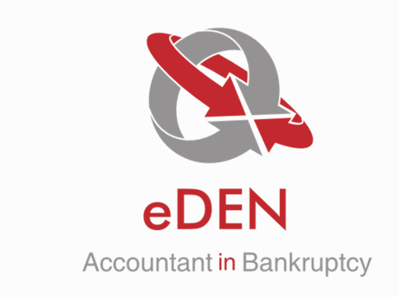

eDEN Internal Release Note
v2.13 & v2.13.1

Contents
1. General 3
1.1 New Users Registering for eDEN - Agree with Guidance & GDPR 3
1.2 AiB Password Policy Updates 3
2. Variations 3
2.1 Remove permission where a Debtor can create a partial settlement variation 3
2.2 Balance adjustment variation 3
2.3 Variation and Discretionary Condition 6
2.4 Money Advisor and Debtors are able to submit a composition variation 6
3. Users 6
3.1 Manager report for Users 6
3.2 Approving New Users 6
4. Help desk 7
4.1 Debtor Payment Schedule Status Error 7
5. Letters 7
5.1 New merge field for Debtor Address for Variation, Variation Proposal and Revocation type letters 7

General

New Users Registering for eDEN - Agree with Guidance & GDPR
The new user registration page has been altered to include the eDEN Data Protection Terms and Conditions. If the check box is not selected to confirm the Users agrees with these terms and conditions, they will be unable to proceed with the registration process

AiB Password Policy Updates
AiB have approved a new password policy which increases the length of passwords from nine characters to twelve with complexity to include upper and lower case characters, numbers and special characters.
The change also includes extending the password validity period to 60 days. These changes will not take effect until the user is notified that their password has expired.

Variations

Remove permission where a Debtor can create a partial settlement variation
The permissions have been adjusted to prevent Debtor’s from creating a Partial Settlement variation. Debtor Users can only create the following variation types;
- Payment Break
- Debt Change
- Contribution Change
- Essential Credit
- Discretionary Condition

Balance adjustment variation
A new variation type has been developed called Balance Adjustment variations which can only be created by Payment Distributor and AiB Users.
To create this variation type, the User must navigate to the Variation section of the DPP and select “Create”. Alternatively, they can select “Create Variation” from the menu on the left hand side.
The User will be redirected to the screen below:
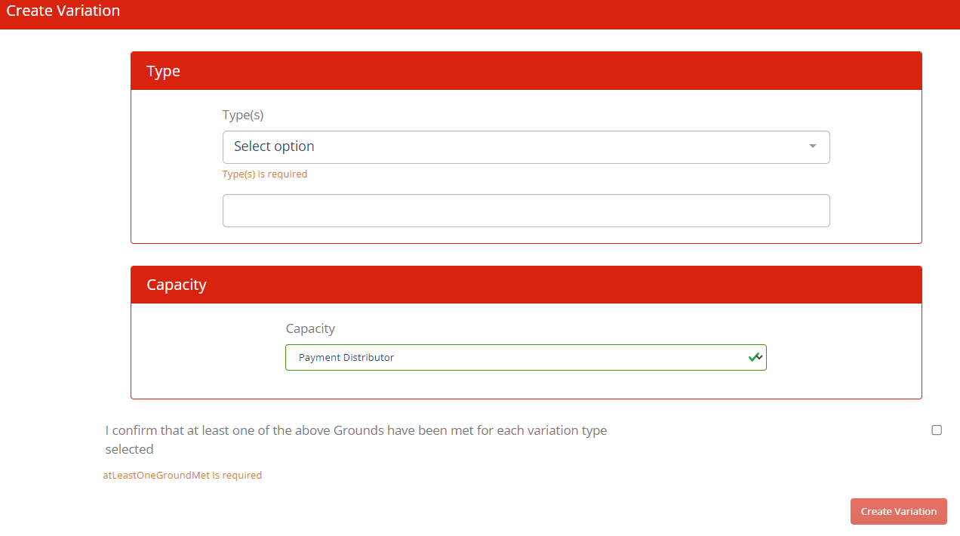
The User must select Balance Adjustment from the Type drop down menu. This will be the only option available to the Payment Distributer User when creating a variation. The capacity will have automatically set to Payment Distributor. The User must select the check box confirming that the grounds have been met for the variation type.
Once that information has been applied, the following criteria will become visible to the User. If a scheduled payment is due within 3 working days of the variation being submitted, the User will be unable to submit the variation and will receive a warning message advising them of this:
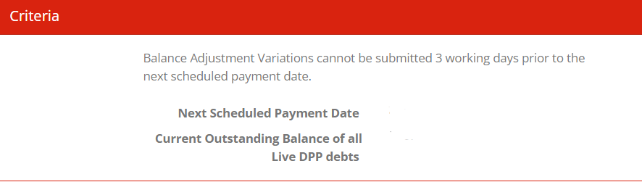
If the variation meets the required criteria, select Create Variation. The User will be navigated to the debts screen. Each debt will have a modify option which will allow the User to apply the necessary changes as shown below:
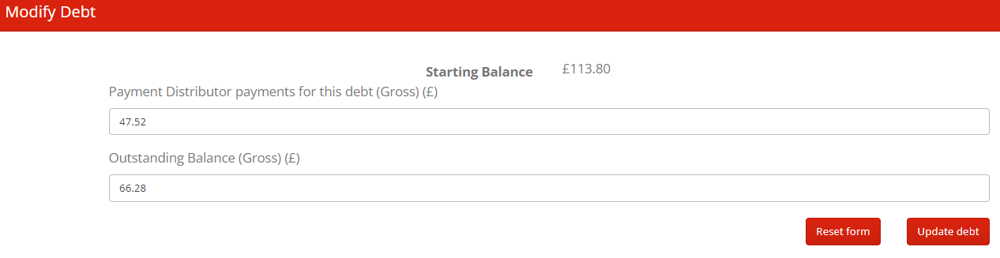
The starting balance must equal the sum of the PD payments for this debt and the outstanding balance. If the User enters the incorrect figures, the following message will become visible when the User attempts to update the debt;
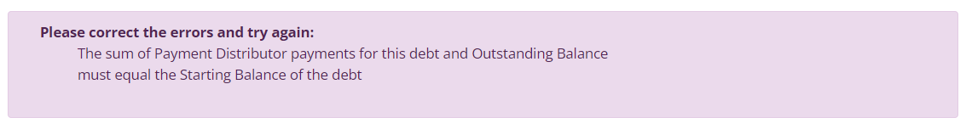
If the correct information is entered, the Users will be taken to the Supporting Information screen where they must upload any supporting documentation, which in most cases will be a full payment report for the case. When the supporting information and a reason for the variation is completed. Once completed, the User can navigate to the submission screen where they can review the Projected Payment Schedule before submitting the variation to AiB.

Once submitted, the case will then populate in the Submitted Balance Adjustment Variations task list which is visible to AIB only;
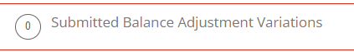
If there are any issues with the variation, this can be returned to the Payment Distributor and will populate in the Returned Balance Adjustment Variations task list which is visible to Payment Distributor and AiB Users:
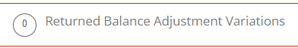
This will require the PD to take any action noted in the return note and then resubmit the variation again. The PD should not that if any payments are entered before resubmission that the amounts entered on the application will need to be updated.
If a User attempts to record a scheduled payment or ad hoc payment when there is submitted Balance Adjustment variation, the following warning message will become visible to them:
This message will also appear when a PD upload is created.
Once checked and approved by the AiB user the application will be approved and update the information on eDEN as per the application. There will be no notification of this variation to creditors, debtors or money advisers as this is for administrative purposes only.

Variation and Discretionary Condition
The variation process was causing complications when a combined Discretionary Condition variation was created e.g. if a variation was created remove/amend an existing Discretionary Condition and increase an instalment amount, the variation would automatically approve because of the instalment increase which would prevent creditors input with regards to the Discretionary Condition.
In order to prevent further difficulties, the create variation process has been altered to prevent more than one variation type being selected if the variation is a Discretionary Condition. If Debt Change type etc is selected, the Discretionary Condition option will automatically be removed from the variation type drop down.

Money Advisor and Debtors are able to submit a composition variation
Permissions have been amended to prevent public Money Advisors and debtors from creating a Composition variation. The permissions have been restricted to a Continuing Money Advisor and AiB.

Users

Manager report for Users
A new task list called Organisation Users has been developed to allow internal and external users with manager access the option to add, remove and update users accounts within their organisation. The information can be exported and a report will be automatically emailed to all managers on a quarterly basis to ensure all Users are still valid.
Please note, this functionality is a notification based task therefore Managers must select the “Send User Notification task” check box in order to receive these reports.

Approving New Users
All external user requests will automatically populate in the New User Request task list which is visible to manager users of that organisation. Any future requests will only populate in the task list for AiB Users if the organisation has not been approved on eDEN. Once the organisations are approved, AiB Users can input the approved organisation which will automatically remove the request from the AiB task list and populate in the external task list.

Help desk

Debtor Payment Schedule Status Error
An issue was raised as it had been identified that the Payment Schedule was not updating when amendments were made to payments therefore the Debtor Payment Schedule status was incorrect. This issue has now been resolved.

Letters

New merge field for Debtor Address for Variation, Variation Proposal and Revocation type letters
Intermittent issues were raised which were related to a merge field where the debtor address was not populating in various letters. The issue has been resolved.

